APP DEVELOPMENT - ANDROID/FLUTTER/FLASK
Experiment 1(a)
Aim : 1. Install Android studio and setup AVD.
ALGORITHM :
- Set-up Java Development Kit (JDK).
download the latest version of Java JDK from Oracle's Java site : https://www.oracle.com/java/technologies/downloads/
- Install Android Studio IDE.
1. Download the latest version from Android Studio- https://developer.android.com/studio
- Launch Android Studio.exe
- After launching Android Studio, mention JDK path in android studio installer.
- Check the components, which are required to create applications,
    - Android Studio, Android SDK
    - Android Virtual Machine
    - Performance (Intel chip)
- Specify the location of local machine path for Android studio and Android SDK
- Specify the RAM space for Android emulator by default it would take 512MB of local machine RAM.
- SDK packages will be extracted into our local machine, it would take a while time to finish the task and would take 2626MB of Hard disk space.
- After done all above steps perfectly, you must get finish button and it going to be open android studio project with Welcome to android studio message.
- Set-up Java Development Kit (JDK)
  - download the latest version of Java JDK from Oracle's Java site-
https://www.oracle.com/java/technologies/downloads/
  - Install Jdk.
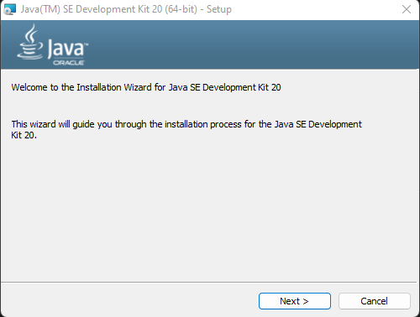

- Install Android IDE
  - Download the latest version from Android Studio Website.
https://developer.android.com/studio?gclid=Cj0KCQjwz6ShBhCMARIsAH9A0qWm659HEaFDNedulP0qbEVHJyzff7pq3KEzBNOLyOF_JTXqfqfc5I0aAn87EALw_wcB&gclsrc=aw.ds
  - Launch Android Studio.exe
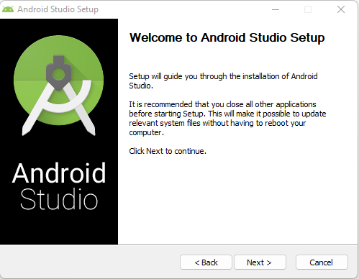
  - Check the components, which are required to create applications,
    - Android Studio, Android SDK
    - Android Virtual Machine
    - Performance (Intel chip).

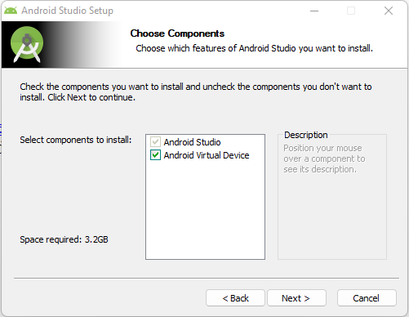
  - Specify the location of local machine path for Android studio and Android SDK.
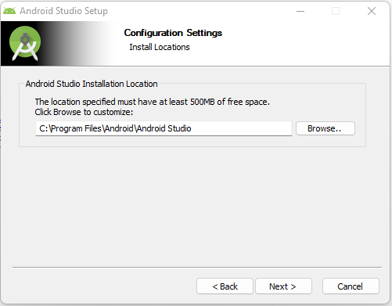

  - Select the Start menu folder
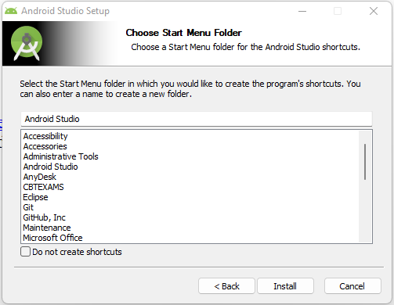
  - After done all above steps perfectly, you must get finish button and it going to be open android studio project with Welcome to android studio message.
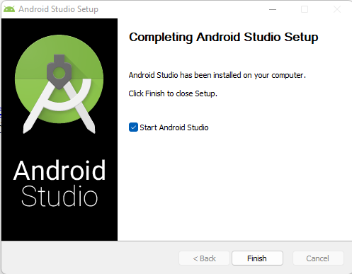

Experimrnt 1(b)
Aim : Develop mobile apps with menu options for Dial number, Open website and Send SMS. On selecting an option, the appropriate action should be invoked using intents.
AlGORITHM :
- Create a simple Android Application using Android studio. When you click on Android studio icon, it will show screen as shown below. Select New project option for creating new project.
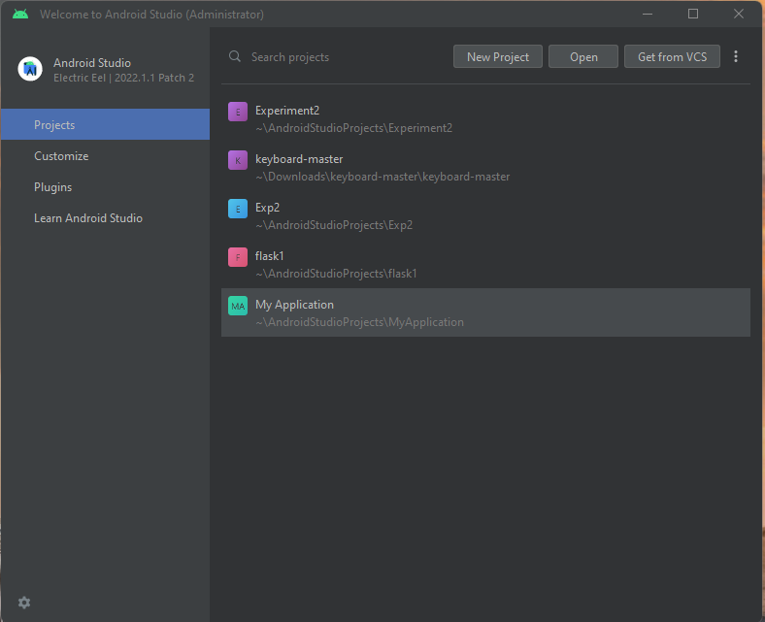
- Select the Empty activity (Layout) and select next button for creating user interface.
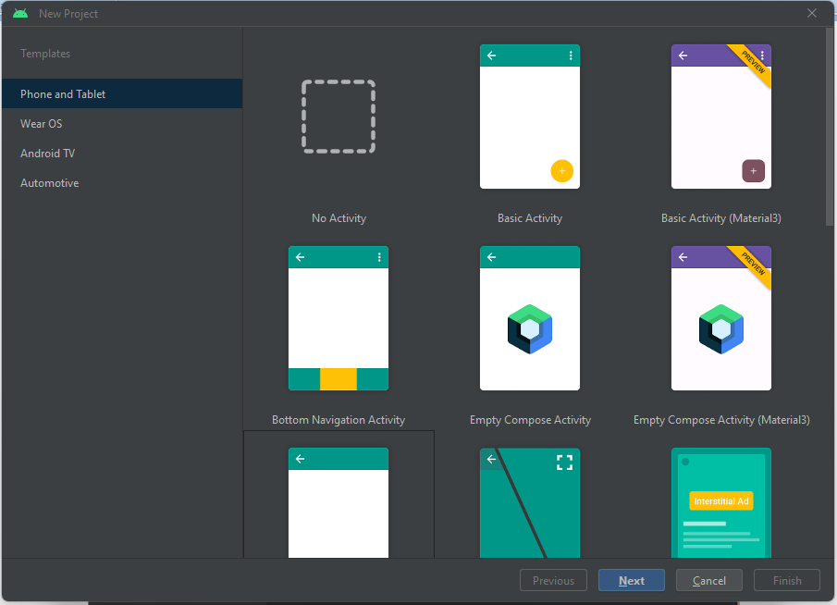

- In this window we have to write the project name, package name, save location, language and minimum SDK version then select finish button.
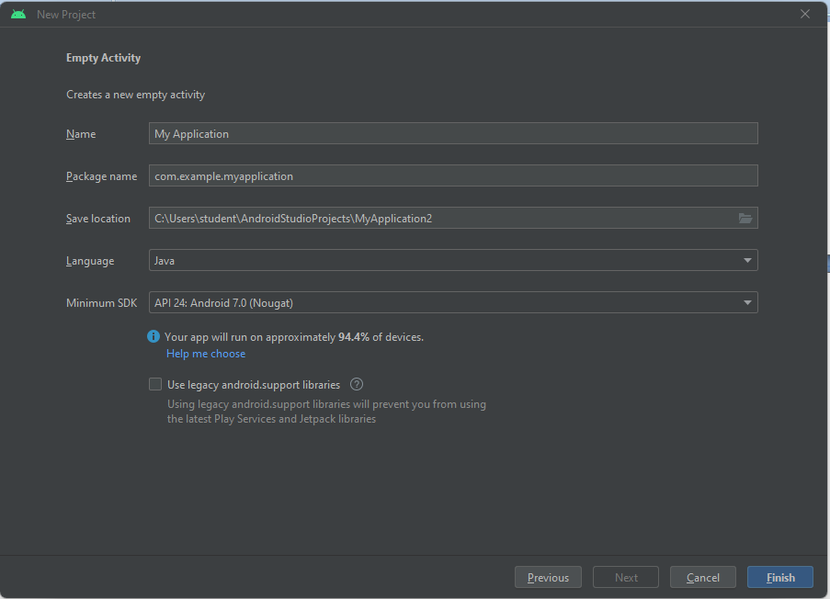
- At the final stage it going to be open development tool to write the application code.

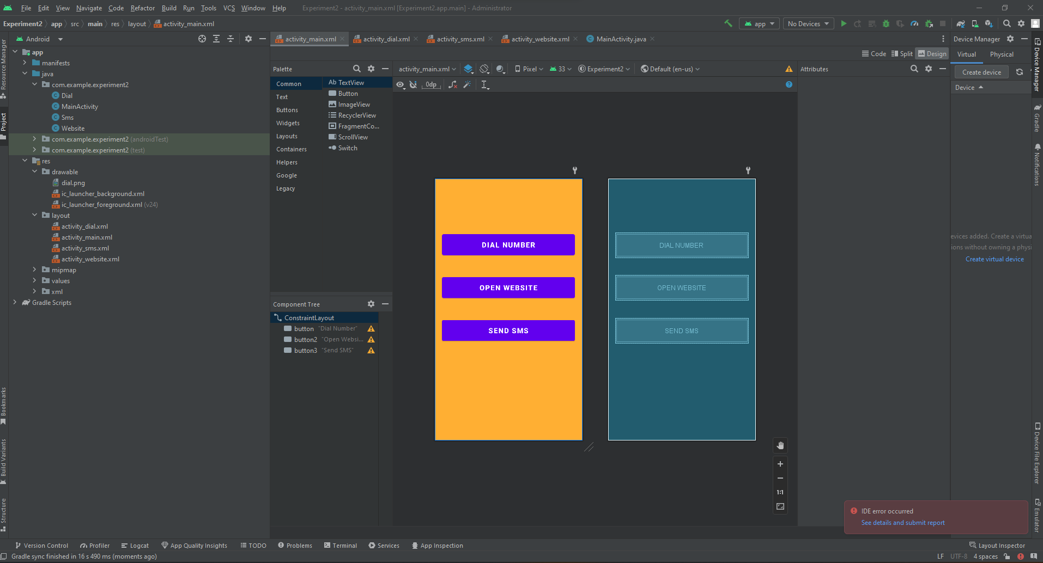

- The activity_main.xml is a layout file available in res/layout directory that is referenced by your application when building its interface. You will modify this file very frequently to change the layout of your application.
  - : Create Dial Activity
  - Create Sms Activity
  - Create Website Activity
activity_main.xml
<?xml version="1.0" encoding="utf-8"?>
<androidx.constraintlayout.widget.ConstraintLayout
xmlns:android="http://schemas.android.com/apk/res/android"
xmlns:app="http://schemas.android.com/apk/res-auto"
xmlns:tools="http://schemas.android.com/tools"
android:layout_width="match_parent"
android:layout_height="match_parent"
android:background="#FFAF33"
tools:context=".MainActivity">
<Button
android:id="@+id/button"
android:layout_width="match_parent"
android:layout_height="70dp"
android:layout_marginStart="20dp"
android:layout_marginTop="150dp"
android:layout_marginEnd="20dp"
android:text="Dial Number"
android:textSize="20dp"
android:textStyle="bold"
app:layout_constraintEnd_toEndOf="parent"
app:layout_constraintStart_toStartOf="parent"
app:layout_constraintTop_toTopOf="parent" />
<Button
android:id="@+id/button2"
android:layout_width="match_parent"
android:layout_height="70dp"
android:layout_marginStart="20dp"
android:layout_marginTop="50dp"
android:layout_marginEnd="20dp"
android:text="Open Website"
android:textSize="20dp"
android:textStyle="bold"
app:layout_constraintEnd_toEndOf="parent"
app:layout_constraintStart_toStartOf="parent"
app:layout_constraintTop_toBottomOf="@+id/button" />
<Button
android:id="@+id/button3"
android:layout_width="match_parent"
android:layout_height="70dp"
android:layout_marginStart="20dp"
android:layout_marginTop="50dp"
android:layout_marginEnd="20dp"
android:text="Send SMS"
android:textSize="20dp"
android:textStyle="bold"
app:layout_constraintEnd_toEndOf="parent"
app:layout_constraintStart_toStartOf="parent"
app:layout_constraintTop_toBottomOf="@+id/button2" />
</androidx.constraintlayout.widget.ConstraintLayout>

- Open MainActivity.java the default code generated by the application wizard for Hello World! Application.
Program :
MainActivity.java
package com.example.experiment2;
import androidx.appcompat.app.AppCompatActivity;
import android.content.Intent;
import android.os.Bundle;
import android.view.View;
import android.widget.Button;
public class MainActivity extends AppCompatActivity {
Button b1,b2,b3;
@Override
protected void onCreate(Bundle savedInstanceState) {
super.onCreate(savedInstanceState);
setContentView(R.layout.activity_main);
b1=findViewById(R.id.button);
b2=findViewById(R.id.button2);
b3=findViewById(R.id.button3);
b1.setOnClickListener(new View.OnClickListener() {
@Override
public void onClick(View view) {
Intent dial=new Intent(MainActivity.this,Dial.class);
startActivity(dial);
}
});
b2.setOnClickListener(new View.OnClickListener() {
@Override
public void onClick(View view) {
Intent sms=new Intent(MainActivity.this,Sms.class);
startActivity(sms);
}
});
b3.setOnClickListener(new View.OnClickListener() {
@Override
public void onClick(View view) {
Intent website=new Intent(MainActivity.this,Website.class);
startActivity(website);
}
});
}
}

activity_dial.xml
<?xml version="1.0" encoding="utf-8"?>
<androidx.constraintlayout.widget.ConstraintLayout xmlns:android="http://schemas.android.com/apk/res/android"
xmlns:app="http://schemas.android.com/apk/res-auto"
xmlns:tools="http://schemas.android.com/tools"
android:layout_width="match_parent"
android:layout_height="match_parent"
android:background="@color/black"
android:layout_gravity="center"
tools:context=".Dial">
<TableLayout
android:layout_width="match_parent"
android:layout_height="match_parent"
tools:layout_editor_absoluteX="1dp"
tools:layout_editor_absoluteY="1dp">
<TableRow
android:layout_width="match_parent"
android:layout_height="match_parent"
android:layout_marginTop="50dp">
<Button android:id="@+id/b1"
android:text="1"
android:layout_height="70dp"
android:layout_width="70dp"
android:layout_marginLeft="50dp"/>
<Button android:id="@+id/b2"
android:text="2"
android:layout_height="70dp"
android:layout_width="70dp"
android:layout_marginLeft="50dp"/>
<Button android:id="@+id/b3"
android:text="3"
android:layout_height="70dp"
android:layout_width="70dp"
android:layout_marginLeft="50dp"/>
</TableRow>
<TableRow
android:layout_width="match_parent"
android:layout_height="match_parent"
android:layout_marginTop="50dp">
<Button android:id="@+id/b4"
android:text="4"
android:layout_height="70dp"
android:layout_width="70dp"
android:layout_marginLeft="50dp"/>
<Button android:id="@+id/b5"
android:text="5"
android:layout_height="70dp"
android:layout_width="70dp"
android:layout_marginLeft="50dp"/>
<Button android:id="@+id/b6"
android:text="6"
android:layout_height="70dp"
android:layout_width="70dp"
android:layout_marginLeft="50dp"/>
</TableRow>
<TableRow
android:layout_width="match_parent"
android:layout_height="match_parent"
android:layout_marginTop="50dp">
<Button android:id="@+id/b7"
android:text="7"
android:layout_height="70dp"
android:layout_width="70dp"
android:layout_marginLeft="50dp"/>
<Button android:id="@+id/b8"
android:text="8"
android:layout_height="70dp"
android:layout_width="70dp"
android:layout_marginLeft="50dp"/>
<Button android:id="@+id/b9"
android:text="9"
android:layout_height="70dp"
android:layout_width="70dp"
android:layout_marginLeft="50dp"/>
</TableRow>
<TableRow
android:layout_width="match_parent"
android:layout_height="match_parent"
android:layout_marginTop="50dp">
<Button android:id="@+id/b11"
android:text="*"
android:layout_height="70dp"
android:layout_width="70dp"
android:layout_marginLeft="50dp"/>
<Button android:id="@+id/b22"
android:text="0"
android:layout_height="70dp"
android:layout_width="70dp"
android:layout_marginLeft="50dp"/>
<Button android:id="@+id/b33"
android:text="#"
android:layout_height="70dp"
android:layout_width="70dp"
android:layout_marginLeft="50dp"/>
</TableRow>
<TableRow
android:layout_width="match_parent"
android:layout_height="match_parent"
android:layout_marginTop="50dp"
android:gravity="center">
<Button android:id="@+id/b111"
android:layout_height="70dp"
android:layout_width="match_parent"
android:background="@drawable/dial"
android:layout_marginLeft="50dp"/>
</TableRow>
</TableLayout>
</androidx.constraintlayout.widget.ConstraintLayout>

Activity_sms.xml
<?xml version="1.0" encoding="utf-8"?>
<androidx.constraintlayout.widget.ConstraintLayout xmlns:android="http://schemas.android.com/apk/res/android"
xmlns:app="http://schemas.android.com/apk/res-auto"
xmlns:tools="http://schemas.android.com/tools"
android:layout_width="match_parent"
android:layout_height="match_parent"
android:background="@color/black"
android:layout_gravity="center"
tools:context=".Sms">
<TextView
android:id="@+id/textView"
android:gravity="center"
android:layout_width="match_parent"
android:layout_height="60dp"
android:layout_marginStart="20dp"
android:layout_marginTop="50dp"
android:layout_marginEnd="20dp"
android:text="Send SMS"
android:textSize="30dp"
android:textStyle="bold"
android:textColor="#FCFCFB"
app:layout_constraintEnd_toEndOf="parent"
app:layout_constraintStart_toStartOf="parent"
app:layout_constraintTop_toTopOf="parent" />
<EditText
android:id="@+id/editTextPhone"
android:layout_width="match_parent"
android:layout_height="60dp"
android:gravity="center"
android:layout_marginStart="20dp"
android:layout_marginTop="50dp"
android:layout_marginEnd="20dp"
android:ems="10"
android:inputType="phone"
android:hint="Enter Mobile No"
android:background="#FCFCFB"
android:maxLength="10"
app:layout_constraintEnd_toEndOf="parent"
app:layout_constraintStart_toStartOf="parent"
app:layout_constraintTop_toBottomOf="@+id/textView" />
<EditText
android:id="@+id/editTextTextPersonName2"
android:layout_width="match_parent"
android:layout_height="200dp"
android:gravity="center"
android:layout_marginStart="20dp"
android:layout_marginTop="50dp"
android:layout_marginEnd="20dp"
android:ems="10"
android:inputType="textPersonName"
android:hint="Enter Message"
android:background="#FCFCFB"
app:layout_constraintEnd_toEndOf="parent"
app:layout_constraintStart_toStartOf="parent"
app:layout_constraintTop_toBottomOf="@+id/editTextPhone" />
<Button
android:id="@+id/button4"
android:layout_width="wrap_content"
android:layout_height="wrap_content"
android:layout_marginStart="20dp"
android:layout_marginTop="50dp"
android:layout_marginEnd="20dp"
android:text="send"
app:layout_constraintEnd_toEndOf="parent"
app:layout_constraintStart_toStartOf="parent"
app:layout_constraintTop_toBottomOf="@+id/editTextTextPersonName2" />
</androidx.constraintlayout.widget.ConstraintLayout>

Activity_website.xml
<?xml version="1.0" encoding="utf-8"?>
<RelativeLayout xmlns:android="http://schemas.android.com/apk/res/android"
xmlns:tools="http://schemas.android.com/tools"
android:layout_width="match_parent"
android:layout_height="match_parent"
android:background="@color/black"
tools:context=".MainActivity">
<LinearLayout
android:layout_marginTop="50dp"
android:layout_width="match_parent"
android:layout_height="wrap_content"
android:id="@+id/layout">
<TextView
android:textSize="20dp"
android:layout_marginTop="5dp"
android:layout_width="wrap_content"
android:layout_height="wrap_content"
android:layout_centerInParent="true"
android:text="https://www."
android:textColor="#FCFCFB"
android:id="@+id/textview" />
<EditText
android:layout_width="match_parent"
android:layout_height="wrap_content"
android:id="@+id/urltxt"
android:textColor="@color/black"
android:layout_marginEnd="20dp"
android:layout_centerInParent="true"
android:alpha="0.7"
android:hint="Enter website Name"
android:background="#FCFCFB"
android:textSize="20dp"
android:padding="10dp"
/>
</LinearLayout>
<Button
android:layout_width="wrap_content"
android:layout_height="wrap_content"
android:text="Search"
android:layout_below="@+id/layout"
android:layout_centerHorizontal="true"
android:layout_marginTop="10dp"
android:id="@+id/gotoURL" />
</RelativeLayout>

Output Screens :
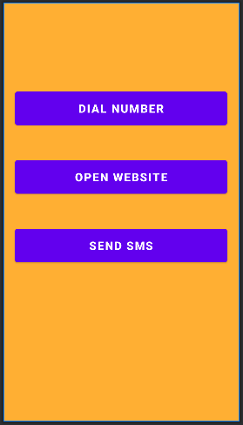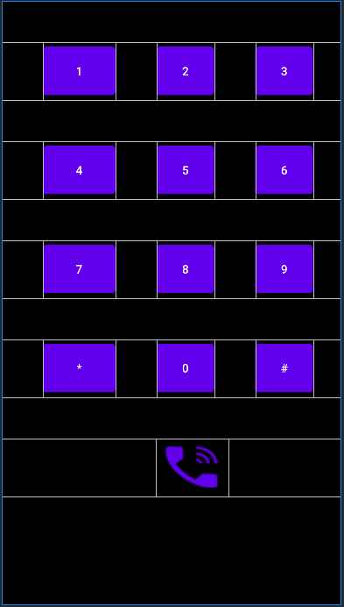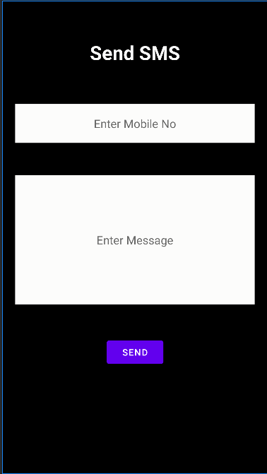

Experiment 2
Aim: Develop mobile apps to insert notifications, on insertion show a toast message.
ALGORITHM :
1. Use Android Studio IDE to create an Android application and name it as Notification under a package com.example.notification (as explained in the Experiment2).

Android Notification
Android Notification provides short, timely information about the action happened in the application, even it is not running. The notification displays the icon, title and some amount of the content text.

Set Android Notification Properties
The properties of Android notification are set using NotificationCompat.Builder object. Some of the notification properties are mention below:
- setSmallIcon(): It sets the icon of notification.
- setContentTitle(): It is used to set the title of notification.
- setContentText(): It is used to set the text message.
- setAutoCancel(): It sets the cancelable property of notification.
- setPriority(): It sets the priority of notification.

Android Notification Example
In this example, we will create a notification message which will launch another activity after clicking on it.

activity_main.xml
Add the following code in an activity_main.xml
<?xml version="1.0" encoding="utf-8"?>
<android.support.constraint.ConstraintLayout xmlns:android="http://schemas.android.com/apk/res/android"
xmlns:app="http://schemas.android.com/apk/res-auto"
xmlns:tools="http://schemas.android.com/tools"
android:layout_width="match_parent"
android:layout_height="match_parent"
tools:context="example.javatpoint.com.androidnotification.MainActivity">

<TextView
android:layout_width="wrap_content"
android:layout_height="wrap_content"
android:text="ANDROID NOTIFICATION"
app:layout_constraintBottom_toBottomOf="parent"
app:layout_constraintLeft_toLeftOf="parent"
app:layout_constraintRight_toRightOf="parent"
app:layout_constraintTop_toTopOf="parent"
app:layout_constraintVertical_bias="0.091"
android:textAppearance="@style/Base.TextAppearance.AppCompat.Medium"/>

<Button
android:layout_width="wrap_content"
android:layout_height="wrap_content"
android:id="@+id/button"
android:layout_marginBottom="112dp"
android:layout_marginEnd="8dp"
android:layout_marginStart="8dp"
android:text="Notify"
app:layout_constraintBottom_toBottomOf="parent"
app:layout_constraintEnd_toEndOf="parent"
app:layout_constraintStart_toStartOf="parent" />

</android.support.constraint.ConstraintLayout>
Create an activity named as activity_notification_view.xml and add the following code. This activity will be launched on clicking the notification. TextView is used to display the notification message.

activity_notification_view.xml
<?xml version="1.0" encoding="utf-8"?>
<android.support.constraint.ConstraintLayout xmlns:android="http://schemas.android.com/apk/res/android"
xmlns:app="http://schemas.android.com/apk/res-auto"
xmlns:tools="http://schemas.android.com/tools"
android:layout_width="match_parent"
android:layout_height="match_parent"
tools:context="example.javatpoint.com.androidnotification.NotificationView">

<TextView
android:id="@+id/textView2"
android:layout_width="fill_parent"
android:layout_height="wrap_content"
android:gravity="center"
android:text="your detail of notification..."
android:textAppearance="@style/Base.TextAppearance.AppCompat.Medium" />

<TextView
android:id="@+id/textView"
android:layout_width="wrap_content"
android:layout_height="wrap_content"
android:layout_marginBottom="8dp"
android:layout_marginEnd="8dp"
android:layout_marginStart="8dp"
android:layout_marginTop="8dp"
app:layout_constraintBottom_toBottomOf="parent"
app:layout_constraintEnd_toEndOf="parent"
app:layout_constraintHorizontal_bias="0.096"
app:layout_constraintStart_toStartOf="parent"
app:layout_constraintTop_toBottomOf="@+id/textView2"
app:layout_constraintVertical_bias="0.206"
android:textAppearance="@style/Base.TextAppearance.AppCompat.Medium"/>

</android.support.constraint.ConstraintLayout>

MainActivity.java
In the MainActivity.java class adds the following code. In this class, clicking the button calls the addNotification() method where we implement the NotificationCompat.Builder object to set the notification properties. The NotificationManager.notify() method is used to display the notification. The Intent class is used to call another activity (NotificationView.java) on taping the notification.
package example.javatpoint.com.androidnotification;

import android.app.NotificationManager;
import android.app.PendingIntent;
import android.content.Context;
import android.content.Intent;
import android.support.v4.app.NotificationCompat;
import android.support.v7.app.AppCompatActivity;
import android.os.Bundle;
import android.view.View;
import android.widget.Button;

public class MainActivity extends AppCompatActivity {
Button button;
@Override
protected void onCreate(Bundle savedInstanceState) {
super.onCreate(savedInstanceState);
setContentView(R.layout.activity_main);
button = findViewById(R.id.button);
button.setOnClickListener(new View.OnClickListener() {
@Override
public void onClick(View v) {
addNotification();
}
});
}

private void addNotification() {
NotificationCompat.Builder builder =
new NotificationCompat.Builder(this)
.setSmallIcon(R.drawable.messageicon) //set icon for notification
.setContentTitle("Notifications Example") //set title of notification
.setContentText("This is a notification message")//this is notification message
.setAutoCancel(true) // makes auto cancel of notification
.setPriority(NotificationCompat.PRIORITY_DEFAULT); //set priority of notification

Intent notificationIntent = new Intent(this, NotificationView.class);
notificationIntent.addFlags(Intent.FLAG_ACTIVITY_CLEAR_TOP);
//notification message will get at NotificationView
notificationIntent.putExtra("message", "This is a notification message");

PendingIntent pendingIntent = PendingIntent.getActivity(this, 0, notificationIntent,
PendingIntent.FLAG_UPDATE_CURRENT);
builder.setContentIntent(pendingIntent);

// Add as notification
NotificationManager manager = (NotificationManager) getSystemService(Context.NOTIFICATION_SERVICE);
manager.notify(0, builder.build());
}
}

NotificationView.java
The NotificationView.java class receives the notification message and is displayed in TextView. This class is invoked while taping the notification.
package example.javatpoint.com.androidnotification;

import android.support.v7.app.AppCompatActivity;
import android.os.Bundle;
import android.widget.TextView;
import android.widget.Toast;

public class NotificationView extends AppCompatActivity {
TextView textView;
@Override
protected void onCreate(Bundle savedInstanceState) {
super.onCreate(savedInstanceState);
setContentView(R.layout.activity_notification_view);
textView = findViewById(R.id.textView);
//getting the notification message
String message=getIntent().getStringExtra("message");
textView.setText(message);
}
}

strings.xml
<resources>
<string name="app_name">AndroidNotification</string>
<string name="notification_activity">NotificationView</string>
</resources>

AndroidManifest.xml
Add the following code in AndroidManifest.xml file.
<?xml version="1.0" encoding="utf-8"?>
<manifest xmlns:android="http://schemas.android.com/apk/res/android"
package="example.javatpoint.com.androidnotification">

<application
android:allowBackup="true"
android:icon="@mipmap/ic_launcher"
android:label="@string/app_name"
android:roundIcon="@mipmap/ic_launcher_round"
android:supportsRtl="true"
android:theme="@style/AppTheme">
<activity android:name=".MainActivity">
<intent-filter>
<action android:name="android.intent.action.MAIN" />

<category android:name="android.intent.category.LAUNCHER" />
</intent-filter>
</activity>
<activity android:name=".NotificationView"
android:label="@string/notification_activity"
android:parentActivityName=".MainActivity">
<meta-data
android:name="android.support.PARENT_ACTIVITY"
android:value=".MainActivity"/>
</activity>
</application>

</manifest>
Output:

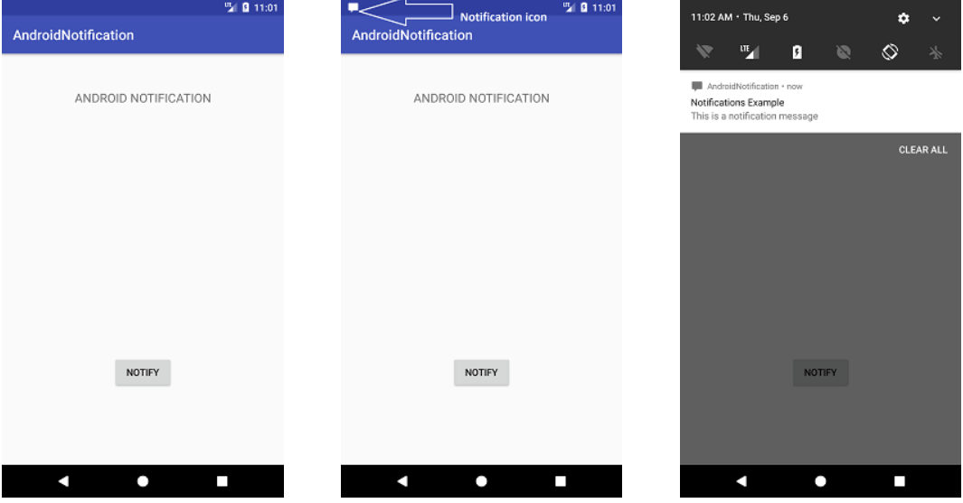

Experiment: 3
Aim: Develop mobile apps with register screen on submission validate and register the user.
Algorithm:
- Use Android Studio IDE to create an Android application and name it as capture image camera under a package “com.android.examples.MainActivity”
- Modify layout XML file res/layout/activity_main.xml add any GUI component if required.
- Modify src/MainActivity.java file to add SQLite database.
- Write Create table and Insert Query in MainActivity.java file.
- Run the application to launch Android emulator and verify the result of the changes done in the application.

- Program:
Write the code in activity_User_Registration.xml
<?xml version="1.0" encoding="utf-8"?>
<androidx.constraintlayout.widget.ConstraintLayout xmlns:android="http://schemas.android.com/apk/res/android"
xmlns:app="http://schemas.android.com/apk/res-auto"
xmlns:tools="http://schemas.android.com/tools"
android:layout_width="match_parent"
android:layout_height="match_parent"
android:background="#B2FD04"
tools:context=".UserRegistration">
<ImageView
android:id="@+id/imageView2"
android:layout_width="200dp"
android:layout_height="200dp"
android:layout_marginEnd="20dp"
android:layout_marginLeft="20dp"
android:layout_marginRight="20dp"
android:layout_marginStart="20dp"
android:layout_marginTop="20dp"
app:layout_constraintEnd_toEndOf="parent"
app:layout_constraintStart_toStartOf="parent"
app:layout_constraintTop_toTopOf="parent"
app:srcCompat="@drawable/icon" />
<EditText
android:id="@+id/editTextTextPersonName"
android:layout_width="match_parent"
android:layout_height="60dp"
android:layout_marginEnd="20dp"
android:layout_marginLeft="20dp"
android:layout_marginRight="20dp"
android:layout_marginStart="20dp"
android:layout_marginTop="20dp"
android:ems="10"
android:hint="Enter User Name"
android:gravity="center"
android:textStyle="bold"
android:textColor="@color/design_default_color_primary"
android:textColorHint="@color/design_default_color_primary"
android:inputType="textPersonName"
android:text="Name"
app:layout_constraintEnd_toEndOf="parent"
app:layout_constraintStart_toStartOf="parent"
app:layout_constraintTop_toBottomOf="@+id/imageView2" />
<EditText
android:id="@+id/editTextTextPassword"
android:layout_width="match_parent"
android:layout_height="60dp"
android:layout_marginEnd="20dp"
android:layout_marginLeft="20dp"
android:layout_marginRight="20dp"
android:layout_marginStart="20dp"
android:layout_marginTop="20dp"
android:ems="10"
android:hint="Enter Password"
android:gravity="center"
android:textStyle="bold"
android:textColor="@color/design_default_color_primary"
android:textColorHint="@color/design_default_color_primary"
android:inputType="textPassword"
app:layout_constraintEnd_toEndOf="parent"
app:layout_constraintStart_toStartOf="parent"
app:layout_constraintTop_toBottomOf="@+id/editTextTextPersonName" />
<EditText
android:id="@+id/editTextTextEmailAddress"
android:layout_width="match_parent"
android:layout_height="60dp"
android:layout_marginEnd="20dp"
android:layout_marginLeft="20dp"
android:layout_marginRight="20dp"
android:layout_marginStart="20dp"
android:layout_marginTop="20dp"
android:ems="10"
android:hint="Enter Email id"
android:gravity="center"
android:textStyle="bold"
android:textColor="@color/design_default_color_primary"
android:textColorHint="@color/design_default_color_primary"
android:inputType="textEmailAddress"
app:layout_constraintEnd_toEndOf="parent"
app:layout_constraintStart_toStartOf="parent"
app:layout_constraintTop_toBottomOf="@+id/editTextTextPassword" />
<EditText
android:id="@+id/editTextPhone"
android:layout_width="match_parent"
android:layout_height="60dp"
android:layout_marginEnd="20dp"
android:layout_marginLeft="20dp"
android:layout_marginRight="20dp"
android:layout_marginStart="20dp"
android:layout_marginTop="20dp"
android:ems="10"
android:hint="Enter Mobile Number"
android:gravity="center"
android:textStyle="bold"
android:textColor="@color/design_default_color_primary"
android:textColorHint="@color/design_default_color_primary"
android:inputType="phone"
app:layout_constraintEnd_toEndOf="parent"
app:layout_constraintStart_toStartOf="parent"
app:layout_constraintTop_toBottomOf="@+id/editTextTextEmailAddress" />
<Button
android:id="@+id/button3"
android:layout_width="match_parent"
android:layout_height="60dp"
android:layout_marginEnd="20dp"
android:layout_marginLeft="20dp"
android:layout_marginRight="20dp"
android:layout_marginStart="20dp"
android:layout_marginTop="20dp"
android:text="Submit"
android:textSize="30sp"
app:layout_constraintEnd_toEndOf="parent"
app:layout_constraintStart_toStartOf="parent"
app:layout_constraintTop_toBottomOf="@+id/editTextPhone" />
</androidx.constraintlayout.widget.ConstraintLayout>

Write the code in UserRegistration.java
import androidx.appcompat.app.AppCompatActivity;
import android.content.Context;
import android.database.sqlite.SQLiteDatabase;
import android.os.Bundle;
import android.view.View;
import android.widget.Button;
import android.widget.EditText;
import android.widget.Toast;
public class UserRegistration extends AppCompatActivity {
EditText uname,upassword,uemail,uphone;
Button sub;
SQLiteDatabase db;
@Override
protected void onCreate(Bundle savedInstanceState) {
super.onCreate(savedInstanceState);
setContentView(R.layout.activity_user_registration);
uname=findViewById(R.id.editTextTextPersonName);
upassword=findViewById(R.id.editTextTextPassword);
uemail=findViewById(R.id.editTextTextEmailAddress);
uphone=findViewById(R.id.editTextPhone);
sub=findViewById(R.id.button3);
db=openOrCreateDatabase("suresh", Context.MODE_PRIVATE,null);
db.execSQL("create table if not exists ureg(id varchar,password varchar,emailid varchar,mobileNo varchar)");
sub.setOnClickListener(new View.OnClickListener() {
@Override
public void onClick(View v) {
if(uname.getText().toString().trim().length()==0||upassword.getText().toString().trim().length()==0||uemail.getText().toString().trim().length()==0||uphone.getText().toString().trim().length()==0)
{
Toast.makeText(UserRegistration.this,"Please enter all the values",Toast.LENGTH_LONG).show();
return;
}
else if(uphone.getText().toString().length()!=10)
{
Toast.makeText(UserRegistration.this,"Please enter 10 Digit Mobile Number",Toast.LENGTH_LONG).show();
return;
}
db.execSQL("insert into ureg values('"+uname.getText()+"','"+upassword.getText()+"','"+uemail.getText()+"','"+uphone.getText()+"');");
Toast.makeText(UserRegistration.this,"Registration Successfull",Toast.LENGTH_LONG).show();
clear();
}
});
}
public void clear()
{
uname.setText("");
upassword.setText("");
uemail.setText("");
uphone.setText("");
}
}

Output Screens:

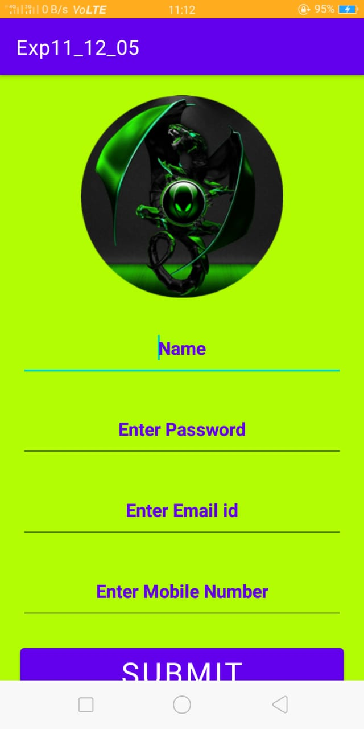

Experiment: 4

Aim: Develop mobile apps with login and welcome screens on submission validate the user details, on success navigate to welcome screen.
Algorithm:
- Use Android Studio IDE to create an Android application and name it as capture image camera under a package “com.android.examples.Login”
- Modify layout XML file res/layout/activity_main.xml add any GUI component if required.
- Modify src/MainActivity.java file to add SQLite database.
- Write Select Query in Login.java file.
- Run the application to launch Android emulator and verify the result of the changes done in the application

Program:
Write the code in activity_login.xml
<?xml version="1.0" encoding="utf-8"?>
<androidx.constraintlayout.widget.ConstraintLayout xmlns:android="http://schemas.android.com/apk/res/android"
xmlns:app="http://schemas.android.com/apk/res-auto"
xmlns:tools="http://schemas.android.com/tools"
android:layout_width="match_parent"
android:layout_height="match_parent"
android:background="#B2FD04"
tools:context=".Login">
<ImageView
android:id="@+id/imageView3"
android:layout_width="wrap_content"
android:layout_height="wrap_content"
android:layout_marginEnd="20dp"
android:layout_marginLeft="20dp"
android:layout_marginRight="20dp"
android:layout_marginStart="20dp"
android:layout_marginTop="20dp"
app:layout_constraintEnd_toEndOf="parent"
app:layout_constraintStart_toStartOf="parent"
app:layout_constraintTop_toTopOf="parent"
app:srcCompat="@drawable/icon" />
<EditText
android:id="@+id/editTextTextPersonName2"
android:layout_width="match_parent"
android:layout_height="60dp"
android:layout_marginEnd="20dp"
android:layout_marginLeft="20dp"
android:layout_marginRight="20dp"
android:layout_marginStart="20dp"
android:layout_marginTop="20dp"
android:ems="10"
android:inputType="textPersonName"
android:hint="Enter User Name"
android:gravity="center"
android:textStyle="bold"
android:textColor="@color/design_default_color_primary"
android:textColorHint="@color/design_default_color_primary"
app:layout_constraintEnd_toEndOf="parent"
app:layout_constraintStart_toStartOf="parent"
app:layout_constraintTop_toBottomOf="@+id/imageView3" />
<EditText
android:id="@+id/editTextTextPassword2"
android:layout_width="match_parent"
android:layout_height="60dp"
android:layout_marginEnd="20dp"
android:layout_marginLeft="20dp"
android:layout_marginRight="20dp"
android:layout_marginStart="20dp"
android:layout_marginTop="20dp"
android:ems="10"
android:hint="Enter Password"
android:gravity="center"
android:textStyle="bold"
android:textColor="@color/design_default_color_primary"
android:textColorHint="@color/design_default_color_primary"
android:inputType="textPassword"
app:layout_constraintEnd_toEndOf="parent"
app:layout_constraintStart_toStartOf="parent"
app:layout_constraintTop_toBottomOf="@+id/editTextTextPersonName2" />
<Button
android:id="@+id/button4"
android:layout_width="match_parent"
android:layout_height="60dp"
android:layout_marginEnd="20dp"
android:layout_marginLeft="20dp"
android:layout_marginRight="20dp"
android:layout_marginStart="20dp"
android:layout_marginTop="20dp"
android:text="Login"
android:textSize="30sp"
android:gravity="center"
android:textStyle="bold"
app:layout_constraintEnd_toEndOf="parent"
app:layout_constraintStart_toStartOf="parent"
app:layout_constraintTop_toBottomOf="@+id/editTextTextPassword2" />
</androidx.constraintlayout.widget.ConstraintLayout>

Write the code in Login.java
import androidx.appcompat.app.AppCompatActivity;
import android.content.Context;
import android.content.Intent;
import android.database.Cursor;
import android.database.sqlite.SQLiteDatabase;
import android.os.Bundle;
import android.view.View;
import android.widget.Button;
import android.widget.EditText;
import android.widget.Toast;
public class Login extends AppCompatActivity {
EditText uname,upassword;
Button login;
SQLiteDatabase db;
@Override
protected void onCreate(Bundle savedInstanceState) {
super.onCreate(savedInstanceState);
setContentView(R.layout.activity_login);
uname=(EditText)findViewById(R.id.editTextTextPersonName2);
upassword=findViewById(R.id.editTextTextPassword2);
login=(Button)findViewById(R.id.button4);
db=openOrCreateDatabase("suresh", Context.MODE_PRIVATE,null);
db.execSQL("create table if not exists ureg(id varchar,password varchar,emailid varchar,mobileNo varchar)");
login.setOnClickListener(new View.OnClickListener() {
@Override
public void onClick(View v) {
if(uname.getText().toString().trim().length()==0||upassword.getText().toString().trim().length()==0)
{
Toast.makeText(Login.this,"Please enter all the values",Toast.LENGTH_LONG).show();
return;
}
Cursor cc=db.rawQuery("select * from ureg where id='"+uname.getText()+"' and password='"+upassword.getText()+"'",null);
if(cc.moveToFirst())
{
Toast.makeText(Login.this,"Login Success",Toast.LENGTH_LONG).show();
Intent ab=new Intent(Login.this,Home.class);
startActivity(ab);
clear();
}
}
});
}
public void clear()
{
uname.setText("");
upassword.setText("");
}
}

Output Screens:

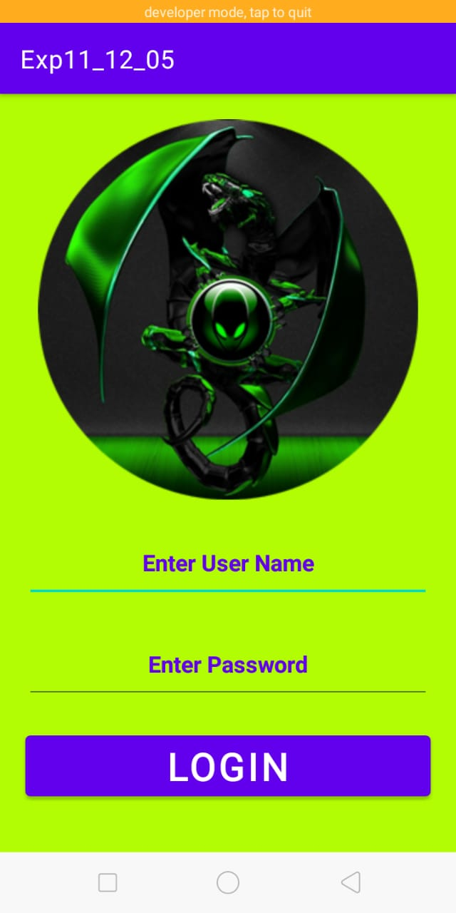

FLUTTER
Experiment 6(a)
Aim : Installing and Configuring Flutter SDK.
ALGORITHM :
- Installing and Configuring Flutter SDK.
  - Download the latest version from flutter-
https://docs.flutter.dev/get-started/install?gclid=Cj0KCQjw27mhBhC9ARIsAIFsETFoRzIcHN-j-g8dkYSpW-lG_0fBD8x3lGvrhQo924spEuVKjpWIlyoaAkF-EALw_wcB&gclsrc=aw.ds
  - Select the operating system on which you are installing Flutter:
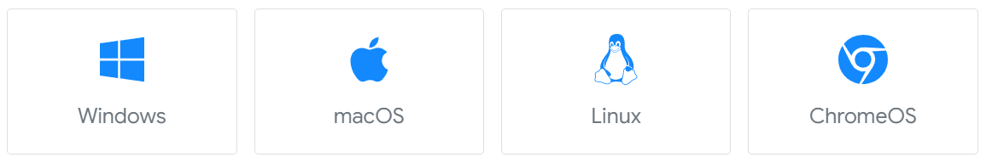
  - Install Git
a. Download the latest version from
https://git-scm.com/download/win
b. download and install 32/64 bit git setup.
c. after installation of git add the git bin path in environment variables.
C:\Program Files\Git\bin
d. if you want to check current version of git run the command in cmd
git –v
  - Get the Flutter SDK
  - Download the following installation bundle to get the latest stable release of the Flutter SDK:
flutter_windows_3.7.10-stable.zip
For other release channels, and older builds, see the SDK releases page.
  - Extract the zip file and place the contained flutter in the desired installation location for the Flutter SDK (for example, C:\src\flutter).
  - Add the flutter bin path in environment variables.
C:\src\flutter\bin
  - Open CMD and write the command it will synchronize the all the files.
flutter doctor.
5. Open android studio select plugins option in that select market place serch for flutter select and install flutter.
6. Open android studio select new flutter project then select flutter and add the path of flutter SDK. Then select new project and write the project name after that select finish button.

Experiment 6 (b)
Aim : Creating a Dart Project Using IntelliJ IDEA.
ALGORITHM : Running Dart code in Intellij IDEA follow the following steps
A. Install Dart SDK
B. Install Intellij IDEA (Community Edition)
C. Add Dart Plugin
- Install Dart SDK
1. Download dart sdk from : https://gekorm.com/dart-windows/
2. Download dart stable version :
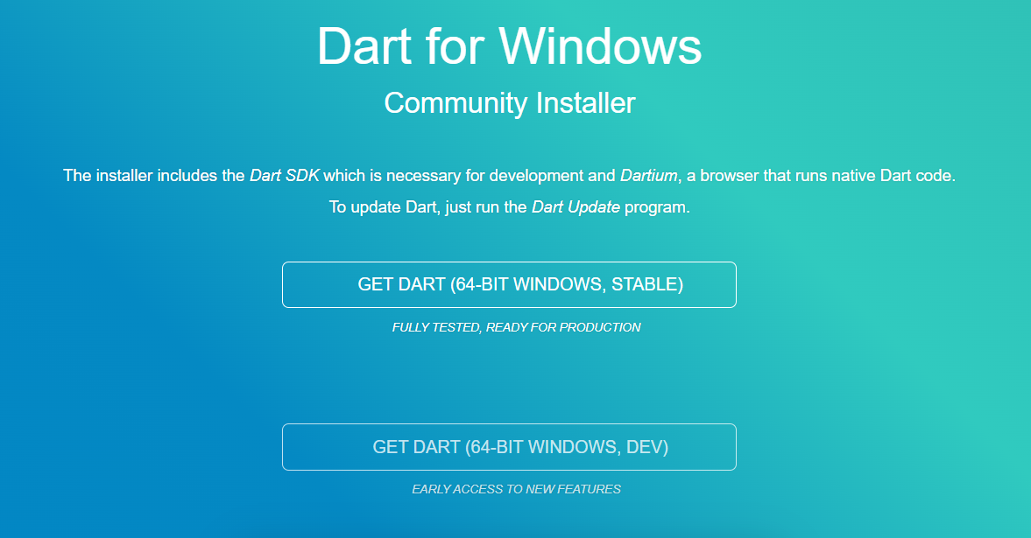
3. After downloading execute the dart exe file. select accept agreement option then select next option.
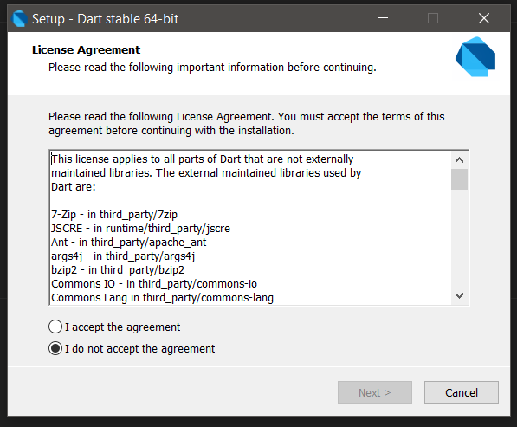
4. Select the next button and set the installation path.
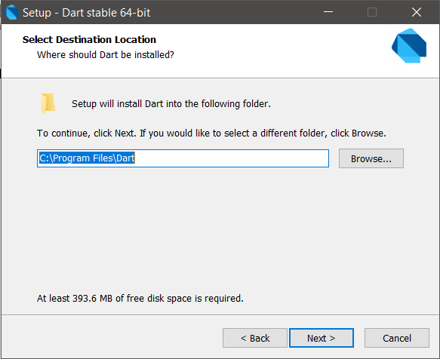
5. Then select next>next>install>next and finish option.
6. After successful installation select window option, on that search dart and select dart update option.
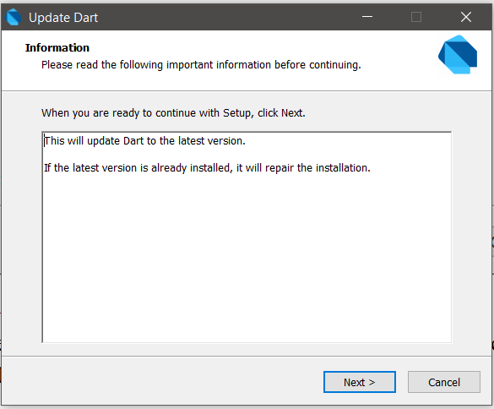
Select next and install options.
- Install Intellij IDE
1. Download intellij IDE from : https://www.jetbrains.com/idea/download/#section=windows
in that website select type of IDE based on operating system and select community Edition.
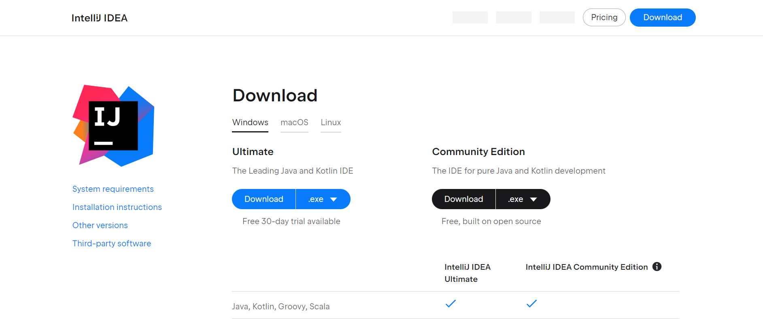
2. After downloading the IDE execute the ideaIC-2023.1.exe file
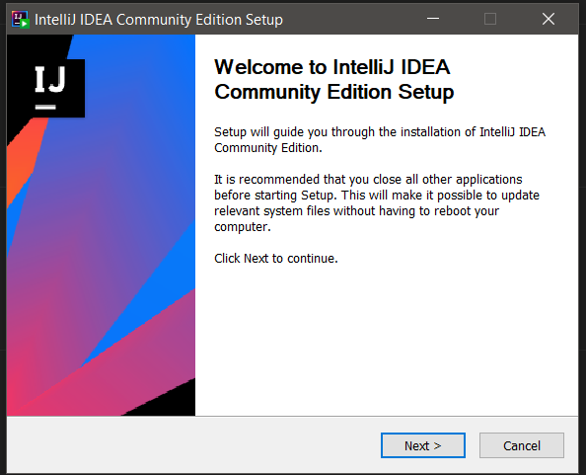
3. Select next>next> and select the update path variable option
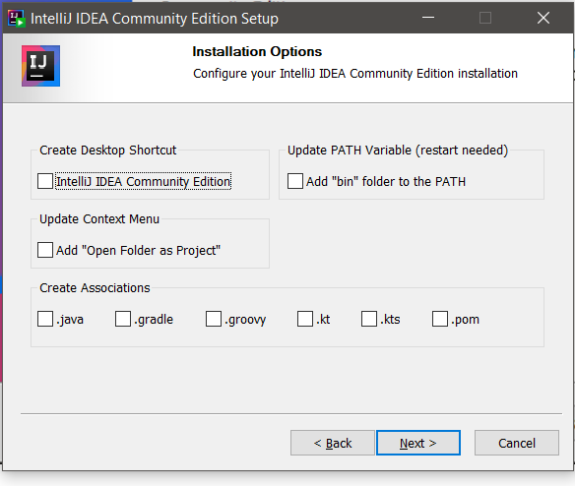
4. Select next and install option.
5. Open Intellij IDE select accept terms and conditions option and select next button.
6. After that select don’t share the data option.
7. Select plugins options search for dart and install dart in IDE.
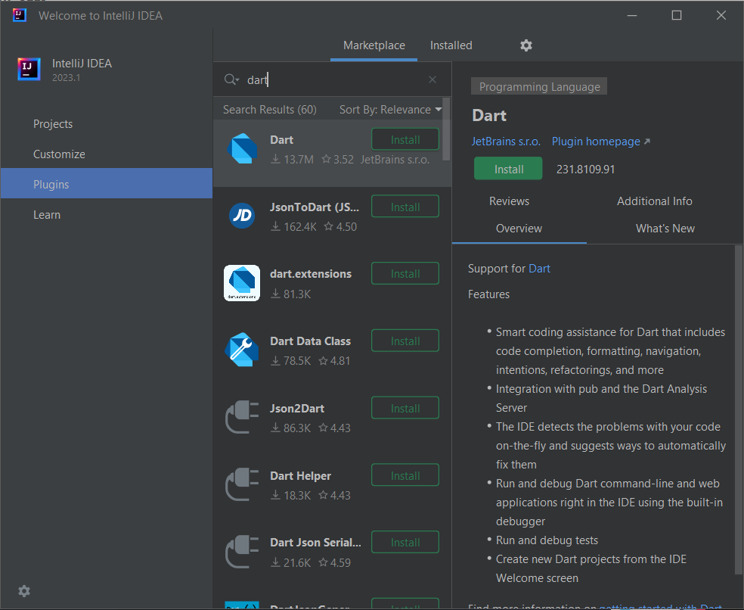
8. After installation select new project and in that select dart option.
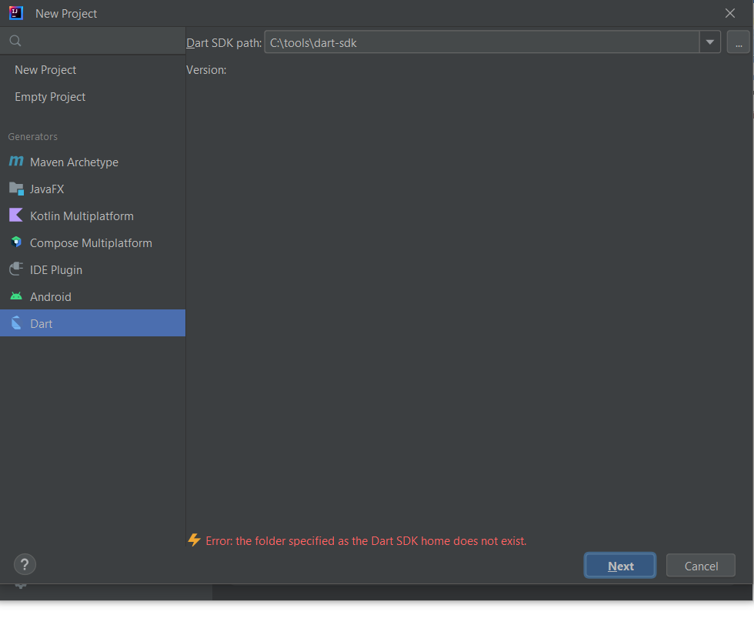
9. Set the dart SDK path
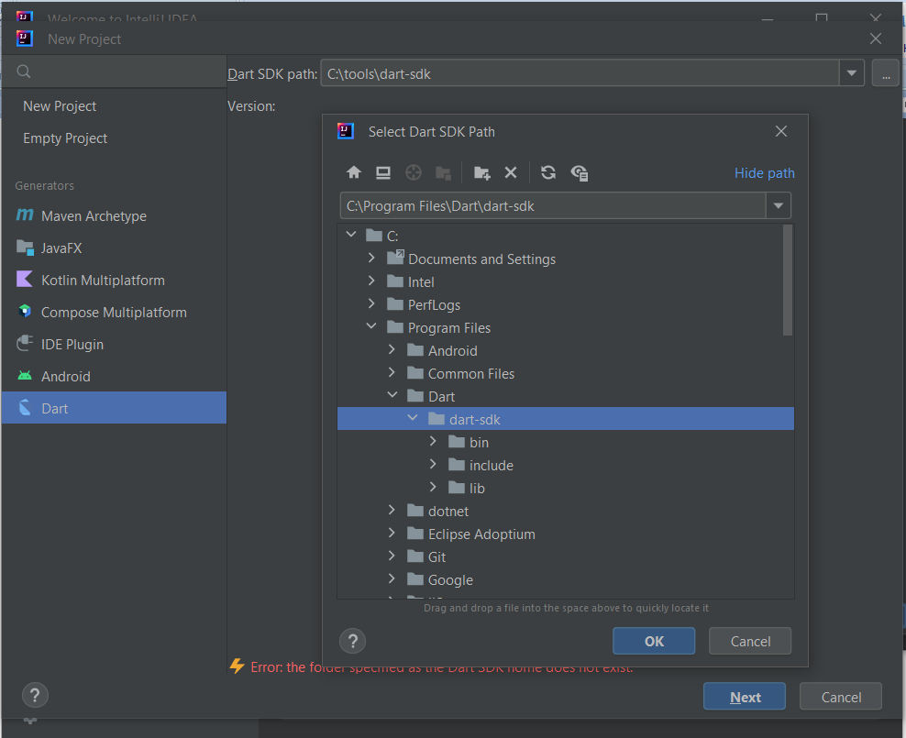
10. Select next button. In that new window write the project name and select create button. The new project is created.
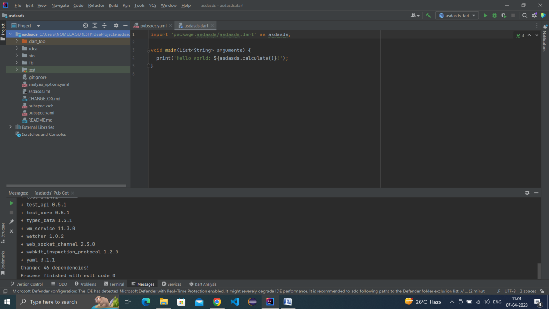
11. In bin folder create new dart file and write the code.
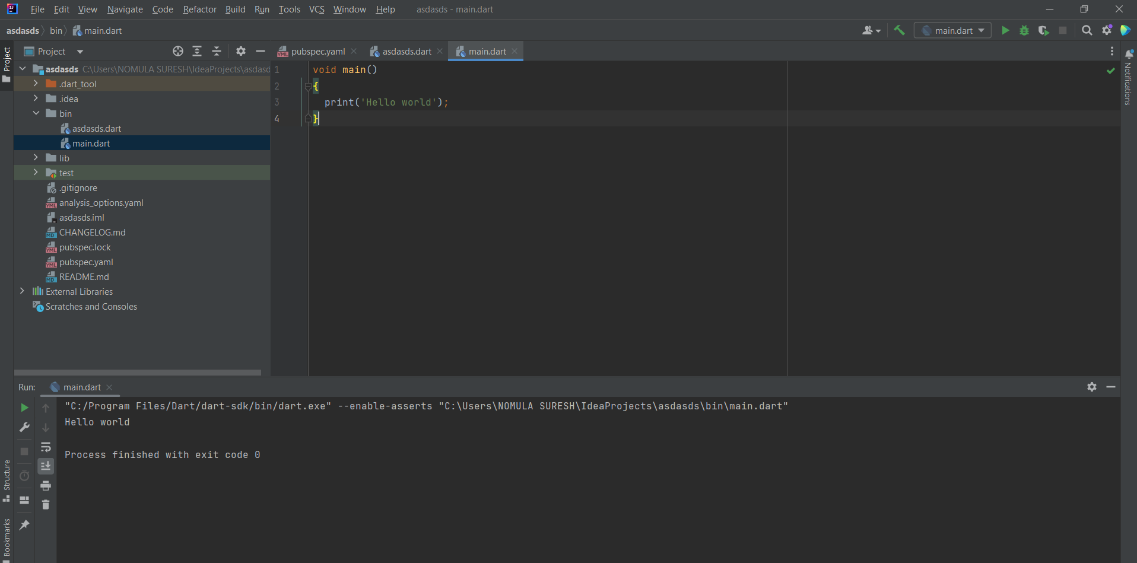

Experiment 7
Aim: Create Navigation and Routing a Pizza Store App.
ALGORITHUM:
- Create the flutter project in android studio.
- Create code and screens folders in lib folder.
- In code folder create the file pizza.dart.
- In screens folder create home, order and review files for creating the user interface.
- Write the code in main.dart file.
Pizza.dart
class pizza
{
static List<String> sizes = <String>["Small", "Medium", "Large"];
String size = sizes.elementAt(0);
Map<String, bool> toppings = new Map<String, bool>();
pizza()
{
toppings.putIfAbsent('Pepperoni', () => false);
toppings.putIfAbsent('Sausage', () => false);
toppings.putIfAbsent('Cheese', () => false);
toppings.putIfAbsent('Pineapple', () => false);
toppings.putIfAbsent('Sardines', () => false);
toppings.putIfAbsent('Onions', () => false);
toppings.putIfAbsent('Mushrooms', () => false);
toppings.putIfAbsent('Peppers', () => false);
toppings.putIfAbsent('Pickles', () => false);
toppings.putIfAbsent('Chocolate', () => false);
toppings.putIfAbsent('Banana', () => false);
toppings.putIfAbsent('Olives', () => false);
}
}

Home.dart
import 'package:flutter/material.dart';
import 'package:pizza_app/screens/order.dart';
class Home extends StatelessWidget
{
@override
Widget build(BuildContext context) {
// TODO: implement build
return new Scaffold(
appBar: new AppBar(title: new Text('Pizza Demo'),),
body: new Center(
child: new Container(
padding: new EdgeInsets.all(32.0),
child: new Column(
children: <Widget>[
new Image.asset('images/pizza.png'),
new ElevatedButton(
child: new Text('Order'),
onPressed: () {Navigator.of(context).pushNamed('/Order');}
)
],
),
),
)
);
}
}

order.dart
import 'package:flutter/material.dart';
import 'package:pizza_app/screens/review.dart';
import 'package:pizza_app/code/pizza.dart';
class Order extends StatefulWidget{
@override
_State createState() => new _State();
}
class _State extends State<Order>{
pizza _pizzaOrder = new pizza();
void _setSize(String value){
setState(() {
_pizzaOrder.size = value;
});
}
void setTopping(int index, bool value){
setState((){
String key = _pizzaOrder.toppings.keys.elementAt(index);
_pizzaOrder.toppings[key] = value;
});
}
@override
Widget build(BuildContext context) {
// TODO: implement build
return new Scaffold(
appBar: new AppBar(title: new Text('Order Pizza'),),
body: new Center(
child: new Container(
padding: new EdgeInsets.all(32.0),
child: new Column(
children: <Widget>[
new DropdownButton(
value: _pizzaOrder.size,
items: pizza.sizes.map((String value)
{
return new DropdownMenuItem<String>(
value: value,
child: new Row(
children: <Widget>[
new Icon(Icons.local_pizza),
new Text('Size: ${value}')
],
),
);
}).toList(),
onChanged: (String value){_setSize(value);}),
new Expanded(
child: new ListView.builder(
shrinkWrap: true,
itemCount: _pizzaOrder.toppings.length,
itemBuilder: (BuildContext context, int index){
return new CheckboxListTile(
controlAffinity: ListTileControlAffinity.leading,
title: new Text(_pizzaOrder.toppings.keys.elementAt(index)),
value: _pizzaOrder.toppings.values.elementAt(index),
onChanged: (bool value){ setTopping(index,value); });
}
)
),
new ElevatedButton(
child: new Text('Continue'),
onPressed: (){
Navigator.push(context, new MaterialPageRoute(
builder: (BuildContext context) => new Review(order: _pizzaOrder,)
));
},
)
]
),
)
),
);
}
}

review.dart
import 'package:flutter/material.dart';
import 'package:pizza_app/code/pizza.dart';
class Review extends StatelessWidget
{
pizza _pizzaOrder;
List<String> _list = new List<String>();
Review({order: null})
{
_pizzaOrder = order;
_list.add("Size: ${_pizzaOrder.size}");
_list.add(" ");
_list.add("Toppings: ");
_pizzaOrder.toppings.forEach((String name, bool value){
if(value) _list.add(name);
});
}
@override
Widget build(BuildContext context)
{
return new Scaffold(
appBar: new AppBar(
title: new Text('Review Pizza Order'),
),
body: new Container(
padding: new EdgeInsets.all(32.0),
child: new Column(
children: <Widget>[
new Text('Review your order', style: new TextStyle(fontWeight: FontWeight.bold),),
new Expanded(child: new ListView.builder(itemBuilder: (BuildContext context, int index){
return new Text(_list.elementAt(index));
},
shrinkWrap: true, itemCount: _list.length,))
],
),
)
);
}
}

main.dart
import 'package:flutter/material.dart';
import 'package:pizza_app/screens/home.dart';
import 'package:pizza_app/screens/order.dart';
import 'package:pizza_app/screens/review.dart';
void main() => runApp(new MyApp());
class MyApp extends StatelessWidget
{
@override
Widget build(BuildContext context) {
// TODO: implement build
return new MaterialApp(
title: 'Navigation',
routes: <String, WidgetBuilder>{
'/Home': (BuildContext context) => new Home(),
'/Order': (BuildContext context) => new Order(),
'/Review': (BuildContext context) => new Review(),
},
home: new Home()
);
}
}

Output Screens.
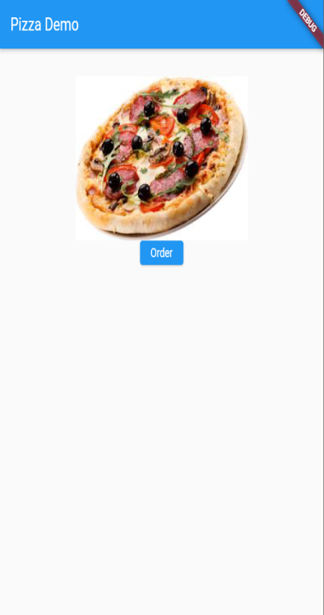 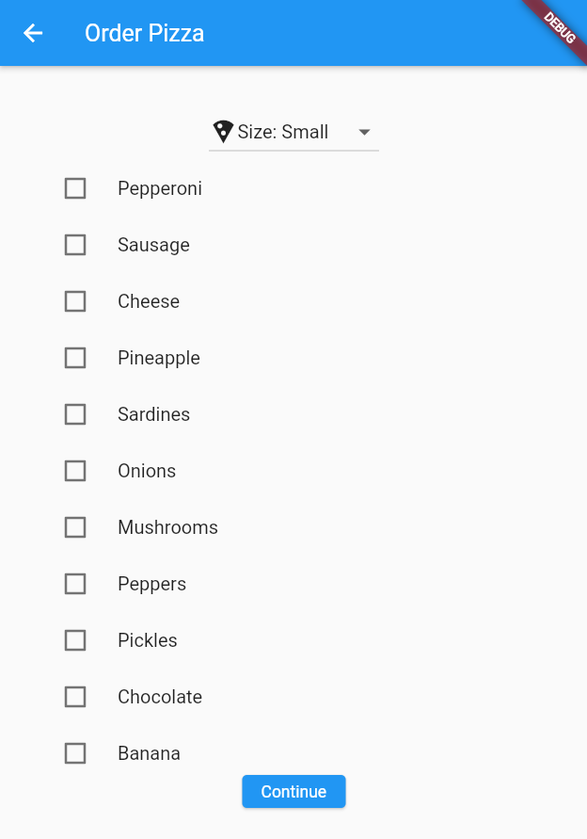 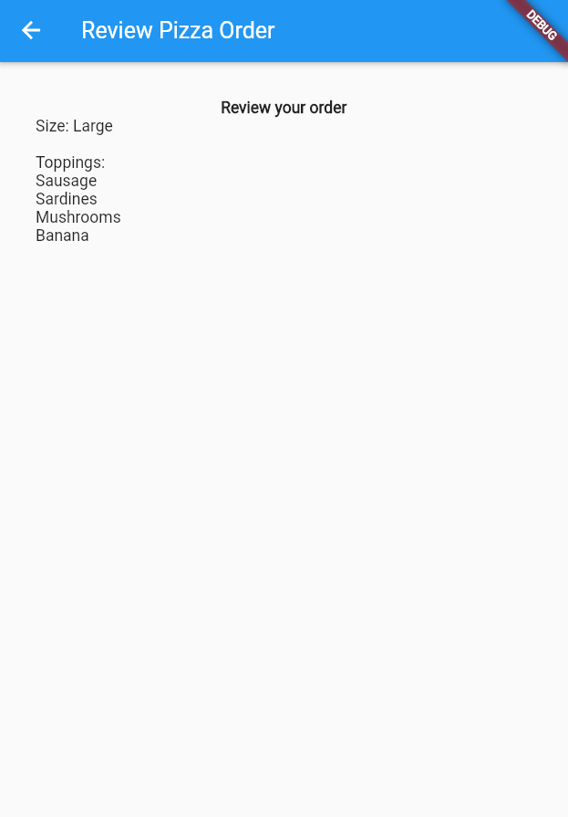

Experiment 7
Aim: Create forgot password option, link to reset using existing email for pizza store App.
ALGORITHUM:
1. Create a dart project Using android Studio.
2. Write the folder name pizza_app_store
3. Write the code in main.dart file
4. Run the code.
CODE:
import 'package:flutter/material.dart';
void main() => runApp(const MyApp());
class MyApp extends StatelessWidget {
const MyApp({Key? key}) : super(key: key);
static const String _title = 'Password Reset Page';
@override
Widget build(BuildContext context) {
return MaterialApp(
title: _title,
home: Scaffold(
appBar: AppBar(title: const Text(_title)),
body: const MyStatefulWidget(),
),
);
}
}
class MyStatefulWidget extends StatefulWidget {
const MyStatefulWidget({Key? key}) : super(key: key);
@override
State<MyStatefulWidget> createState() => _MyStatefulWidgetState();
}
class _MyStatefulWidgetState extends State<MyStatefulWidget> {
TextEditingController nameController = TextEditingController();
TextEditingController passwordController = TextEditingController();
@override
Widget build(BuildContext context) {
return Padding(
padding: const EdgeInsets.all(10),
child: ListView(
children: <Widget>[
Container(
alignment: Alignment.center,
padding: const EdgeInsets.all(10),
child: const Text(
'Online Pizza app Store',
style: TextStyle(
color: Colors.blue,
fontWeight: FontWeight.w500,
fontSize: 30),
)),
Container(
alignment: Alignment.center,
padding: const EdgeInsets.all(10),
child: const Text(
'Forgot Password',
style: TextStyle(fontSize: 20),
)),
Container(
padding: const EdgeInsets.all(10),
child: TextField(
controller: nameController,
decoration: const InputDecoration(
border: OutlineInputBorder(),
labelText: 'Enter Existing Email id',
),
),
),
Container(
padding: const EdgeInsets.fromLTRB(10, 10, 10, 0),
child: TextField(
obscureText: true,
controller: passwordController,
decoration: const InputDecoration(
border: OutlineInputBorder(),
labelText: 'Confirm Email id',
),
),
),
TextButton(
onPressed: () {
//forgot password screen
},
child: const Text('',),
),
Container(
height: 50,
padding: const EdgeInsets.fromLTRB(10, 0, 10, 0),
child: ElevatedButton(
child: const Text('Send Reset Link'),
onPressed: () {
print(nameController.text);
print(passwordController.text);
},
)
),
Row(
children: <Widget>[
const Text('Does not have account?'),
TextButton(
child: const Text(
'Sign in',
style: TextStyle(fontSize: 20),
),
onPressed: () {
//signup screen
},
)
],
mainAxisAlignment: MainAxisAlignment.center,
),
],
));
}
}

OutPut Screen :
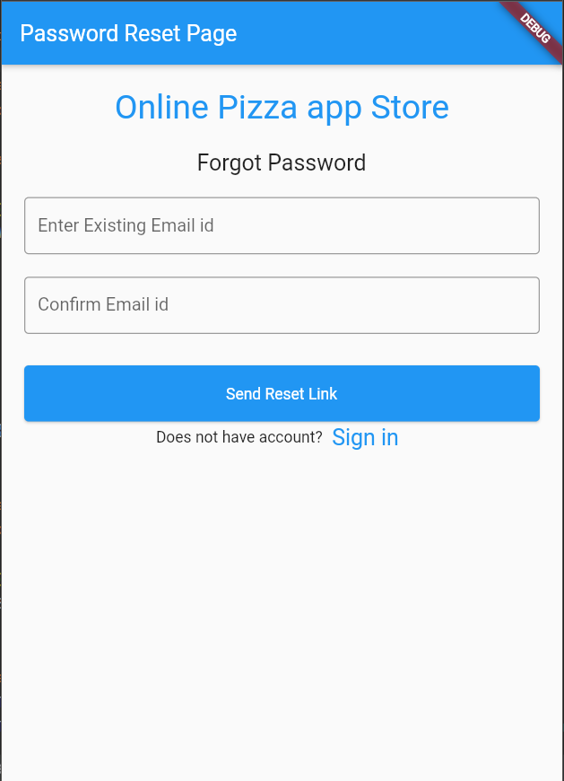

Experiment 8
Aim: Create a User Profile Interface using Firebase.
ALGORITHM :
- Open the firebase console by using the following link.
https://firebase.google.com/
- Select signin option and create the account by using your gmail account.
- Create the flutter project in android studio.
- After creating the project create folder (common and pages) in lib folder.
- Create widget folder in pages folder and create the user interface files in that folder.
- Create the files like splash screen, login and registration files in pages folder.
- Write the code in main.dart file.
CODE :
Splash_screen.dart
import 'dart:async';
import 'package:flutter/material.dart';
import 'login_page.dart';
class SplashScreen extends StatefulWidget {
SplashScreen({Key? key, required this.title}) : super(key: key);
final String title;
@override
_SplashScreenState createState() => _SplashScreenState();
}
class _SplashScreenState extends State<SplashScreen> {
bool _isVisible = false;
_SplashScreenState(){
new Timer(const Duration(milliseconds: 2000), (){
setState(() {
Navigator.of(context).pushAndRemoveUntil(
MaterialPageRoute(builder: (context) => LoginPage()), (route) => false);
});
});
new Timer(
Duration(milliseconds: 10),(){
setState(() {
_isVisible = true; // Now it is showing fade effect and navigating to Login page
});
}
);
}
@override
Widget build(BuildContext context) {
return Container(
decoration: new BoxDecoration(
gradient: new LinearGradient(
colors: [Theme.of(context).accentColor, Theme.of(context).primaryColor],
begin: const FractionalOffset(0, 0),
end: const FractionalOffset(1.0, 0.0),
stops: [0.0, 1.0],
tileMode: TileMode.clamp,
),
),
child: AnimatedOpacity(
opacity: _isVisible ? 1.0 : 0,
duration: Duration(milliseconds: 1200),
child: Center(
child: Container(
height: 140.0,
width: 140.0,
child: Center(
child: ClipOval(
child: Icon(Icons.android_outlined, size: 128,), //put your logo here
),
),
decoration: BoxDecoration(
shape: BoxShape.circle,
color: Colors.white,
boxShadow: [
BoxShadow(
color: Colors.black.withOpacity(0.3),
blurRadius: 2.0,
offset: Offset(5.0, 3.0),
spreadRadius: 2.0,
)
]
),
),
),
),
);
}
}

Login_page.dart
import 'package:flutter/cupertino.dart';
import 'package:flutter/gestures.dart';
import 'package:flutter/material.dart';
import 'package:flutter_login_ui/common/theme_helper.dart';
import 'forgot_password_page.dart';
import 'profile_page.dart';
import 'registration_page.dart';
import 'widgets/header_widget.dart';
class LoginPage extends StatefulWidget{
const LoginPage({Key? key}): super(key:key);
@override
_LoginPageState createState() => _LoginPageState();
}
class _LoginPageState extends State<LoginPage>{
double _headerHeight = 250;
Key _formKey = GlobalKey<FormState>();
@override
Widget build(BuildContext context) {
return Scaffold(
backgroundColor: Colors.white,
body: SingleChildScrollView(
child: Column(
children: [
Container(
height: _headerHeight,
child: HeaderWidget(_headerHeight, true, Icons.login_rounded), //let's create a common header widget
),
SafeArea(
child: Container(
padding: EdgeInsets.fromLTRB(20, 10, 20, 10),
margin: EdgeInsets.fromLTRB(20, 10, 20, 10),// This will be the login form
child: Column(
children: [
Text(
'Hello',
style: TextStyle(fontSize: 60, fontWeight: FontWeight.bold),
),
Text(
'Signin into your account',
style: TextStyle(color: Colors.grey),
),
SizedBox(height: 30.0),
Form(
key: _formKey,
child: Column(
children: [
Container(
child: TextField(
decoration: ThemeHelper().textInputDecoration('User Name', 'Enter your user name'),
),
decoration: ThemeHelper().inputBoxDecorationShaddow(),
),
SizedBox(height: 30.0),
Container(
child: TextField(
obscureText: true,
decoration: ThemeHelper().textInputDecoration('Password', 'Enter your password'),
),
decoration: ThemeHelper().inputBoxDecorationShaddow(),
),
SizedBox(height: 15.0),
Container(
margin: EdgeInsets.fromLTRB(10,0,10,20),
alignment: Alignment.topRight,
child: GestureDetector(
onTap: () {
Navigator.push( context, MaterialPageRoute( builder: (context) => ForgotPasswordPage()), );
},
child: Text( "Forgot your password?", style: TextStyle( color: Colors.grey, ),
),
),
),
Container(
decoration: ThemeHelper().buttonBoxDecoration(context),
child: ElevatedButton(
style: ThemeHelper().buttonStyle(),
child: Padding(
padding: EdgeInsets.fromLTRB(40, 10, 40, 10),
child: Text('Sign In'.toUpperCase(), style: TextStyle(fontSize: 20, fontWeight: FontWeight.bold, color: Colors.white),),
),
onPressed: (){
//After successful login we will redirect to profile page. Let's create profile page now
Navigator.pushReplacement(context, MaterialPageRoute(builder: (context) => ProfilePage()));
},
),
),
Container(
margin: EdgeInsets.fromLTRB(10,20,10,20),
//child: Text('Don\'t have an account? Create'),
child: Text.rich(
TextSpan(
children: [
TextSpan(text: "Don\'t have an account? "),
TextSpan(
text: 'Create',
recognizer: TapGestureRecognizer()
..onTap = (){
Navigator.push(context, MaterialPageRoute(builder: (context) => RegistrationPage()));
},
style: TextStyle(fontWeight: FontWeight.bold, color: Theme.of(context).accentColor),
),
]
)
),
),
],
)
),
],
)
),
),
],
),
),
);
}
}

Registration_page.dart
import 'package:flutter/cupertino.dart';
import 'package:flutter/material.dart';
import 'package:flutter_login_ui/common/theme_helper.dart';
import 'package:flutter_login_ui/pages/widgets/header_widget.dart';
import 'package:font_awesome_flutter/font_awesome_flutter.dart';
import 'package:hexcolor/hexcolor.dart';
import 'profile_page.dart';
class RegistrationPage extends StatefulWidget{
@override
State<StatefulWidget> createState() {
return _RegistrationPageState();
}
}
class _RegistrationPageState extends State<RegistrationPage>{
final _formKey = GlobalKey<FormState>();
bool checkedValue = false;
bool checkboxValue = false;
@override
Widget build(BuildContext context) {
return Scaffold(
backgroundColor: Colors.white,
body: SingleChildScrollView(
child: Stack(
children: [
Container(
height: 150,
child: HeaderWidget(150, false, Icons.person_add_alt_1_rounded),
),
Container(
margin: EdgeInsets.fromLTRB(25, 50, 25, 10),
padding: EdgeInsets.fromLTRB(10, 0, 10, 0),
alignment: Alignment.center,
child: Column(
children: [
Form(
key: _formKey,
child: Column(
children: [
GestureDetector(
child: Stack(
children: [
Container(
padding: EdgeInsets.all(10),
decoration: BoxDecoration(
borderRadius: BorderRadius.circular(100),
border: Border.all(
width: 5, color: Colors.white),
color: Colors.white,
boxShadow: [
BoxShadow(
color: Colors.black12,
blurRadius: 20,
offset: const Offset(5, 5),
),
],
),
child: Icon(
Icons.person,
color: Colors.grey.shade300,
size: 80.0,
),
),
Container(
padding: EdgeInsets.fromLTRB(80, 80, 0, 0),
child: Icon(
Icons.add_circle,
color: Colors.grey.shade700,
size: 25.0,
),
),
],
),
),
SizedBox(height: 30,),
Container(
child: TextFormField(
decoration: ThemeHelper().textInputDecoration('First Name', 'Enter your first name'),
),
decoration: ThemeHelper().inputBoxDecorationShaddow(),
),
SizedBox(height: 30,),
Container(
child: TextFormField(
decoration: ThemeHelper().textInputDecoration('Last Name', 'Enter your last name'),
),
decoration: ThemeHelper().inputBoxDecorationShaddow(),
),
SizedBox(height: 20.0),
Container(
child: TextFormField(
decoration: ThemeHelper().textInputDecoration("E-mail address", "Enter your email"),
keyboardType: TextInputType.emailAddress,
validator: (val) {
if(!(val!.isEmpty) && !RegExp(r"^[a-zA-Z0-9.!#$%&'*+/=?^_`{|}~-]+@[a-zA-Z0-9](?:[a-zA-Z0-9-]{0,253}[a-zA-Z0-9])?(?:\.[a-zA-Z0-9](?:[a-zA-Z0-9-]{0,253}[a-zA-Z0-9])?)*$").hasMatch(val)){
return "Enter a valid email address";
}
return null;
},
),
decoration: ThemeHelper().inputBoxDecorationShaddow(),
),
SizedBox(height: 20.0),
Container(
child: TextFormField(
decoration: ThemeHelper().textInputDecoration(
"Mobile Number",
"Enter your mobile number"),
keyboardType: TextInputType.phone,
validator: (val) {
if(!(val!.isEmpty) && !RegExp(r"^(\d+)*$").hasMatch(val)){
return "Enter a valid phone number";
}
return null;
},
),
decoration: ThemeHelper().inputBoxDecorationShaddow(),
),
SizedBox(height: 20.0),
Container(
child: TextFormField(
obscureText: true,
decoration: ThemeHelper().textInputDecoration(
"Password*", "Enter your password"),
validator: (val) {
if (val!.isEmpty) {
return "Please enter your password";
}
return null;
},
),
decoration: ThemeHelper().inputBoxDecorationShaddow(),
),
SizedBox(height: 15.0),
FormField<bool>(
builder: (state) {
return Column(
children: <Widget>[
Row(
children: <Widget>[
Checkbox(
value: checkboxValue,
onChanged: (value) {
setState(() {
checkboxValue = value!;
state.didChange(value);
});
}),
Text("I accept all terms and conditions.", style: TextStyle(color: Colors.grey),),
],
),
Container(
alignment: Alignment.centerLeft,
child: Text(
state.errorText ?? '',
textAlign: TextAlign.left,
style: TextStyle(color: Theme.of(context).errorColor,fontSize: 12,),
),
)
],
);
},
validator: (value) {
if (!checkboxValue) {
return 'You need to accept terms and conditions';
} else {
return null;
}
},
),
SizedBox(height: 20.0),
Container(
decoration: ThemeHelper().buttonBoxDecoration(context),
child: ElevatedButton(
style: ThemeHelper().buttonStyle(),
child: Padding(
padding: const EdgeInsets.fromLTRB(40, 10, 40, 10),
child: Text(
"Register".toUpperCase(),
style: TextStyle(
fontSize: 20,
fontWeight: FontWeight.bold,
color: Colors.white,
),
),
),
onPressed: () {
if (_formKey.currentState!.validate()) {
Navigator.of(context).pushAndRemoveUntil(
MaterialPageRoute(
builder: (context) => ProfilePage()
),
(Route<dynamic> route) => false
);
}
},
),
),
SizedBox(height: 30.0),
Text("Or create account using social media", style: TextStyle(color: Colors.grey),),
SizedBox(height: 25.0),
Row(
mainAxisAlignment: MainAxisAlignment.center,
children: [
GestureDetector(
child: FaIcon(
FontAwesomeIcons.googlePlus, size: 35,
color: HexColor("#EC2D2F"),),
onTap: () {
setState(() {
showDialog(
context: context,
builder: (BuildContext context) {
return ThemeHelper().alartDialog("Google Plus","You tap on GooglePlus social icon.",context);
},
);
});
},
),
SizedBox(width: 30.0,),
GestureDetector(
child: Container(
padding: EdgeInsets.all(0),
decoration: BoxDecoration(
borderRadius: BorderRadius.circular(100),
border: Border.all(width: 5, color: HexColor("#40ABF0")),
color: HexColor("#40ABF0"),
),
child: FaIcon(
FontAwesomeIcons.twitter, size: 23,
color: HexColor("#FFFFFF"),),
),
onTap: () {
setState(() {
showDialog(
context: context,
builder: (BuildContext context) {
return ThemeHelper().alartDialog("Twitter","You tap on Twitter social icon.",context);
},
);
});
},
),
SizedBox(width: 30.0,),
GestureDetector(
child: FaIcon(
FontAwesomeIcons.facebook, size: 35,
color: HexColor("#3E529C"),),
onTap: () {
setState(() {
showDialog(
context: context,
builder: (BuildContext context) {
return ThemeHelper().alartDialog("Facebook",
"You tap on Facebook social icon.",
context);
},
);
});
},
),
],
),
],
),
),
],
),
),
],
),
),
);
}
}
Output Screens :
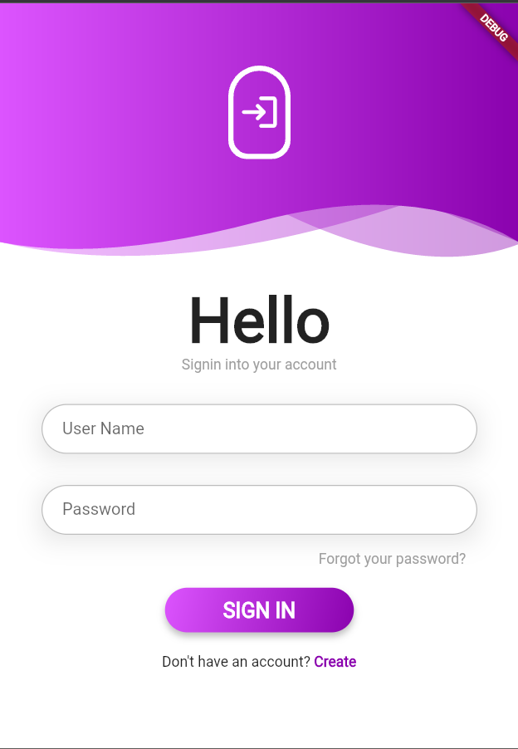 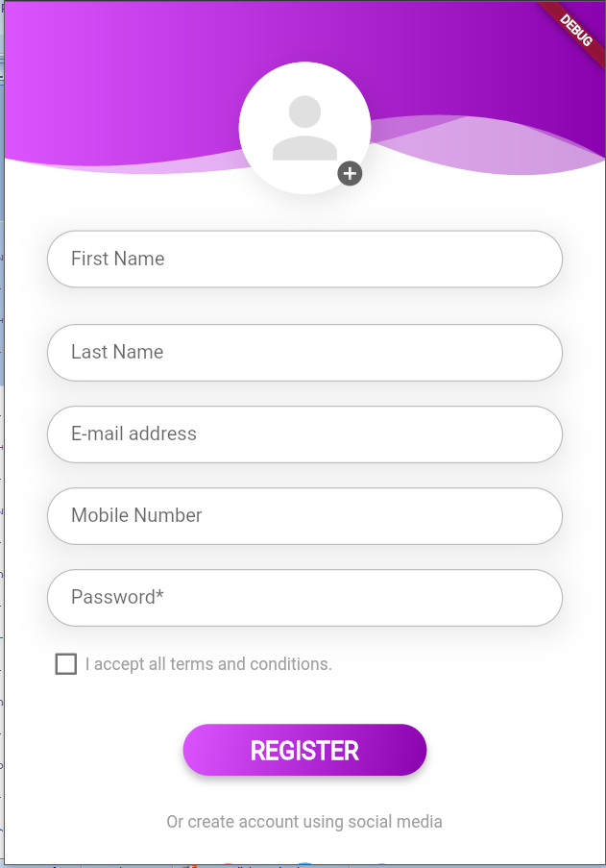

Experiment 9 (a)
Aim : Setup a virtual environment for Flask..
ALGORITHM : Setup a virtual environment for Flask.
- Download python IDE from below link.
https://www.python.org/
- After downloading the IDE execute the python-3.11.3-amd64.exe file
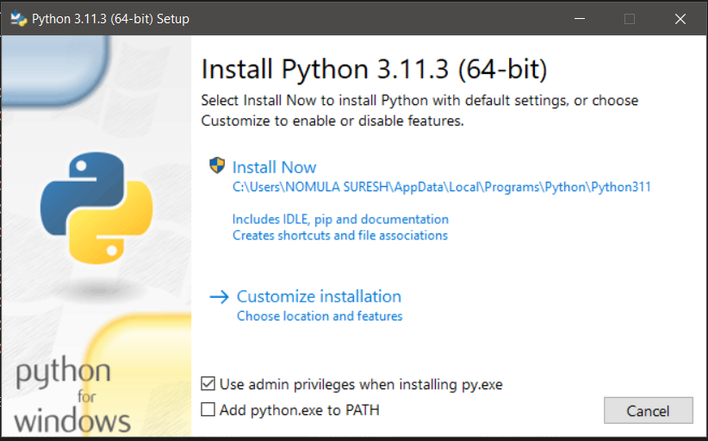
- Select Customize installation option after that select all the checkboxes and select next button.
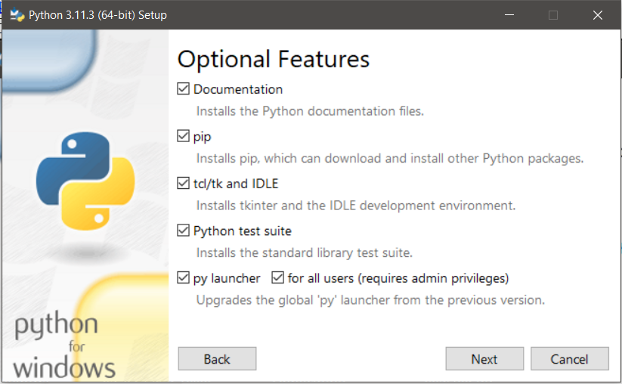
- In that new window select below option and select install option.
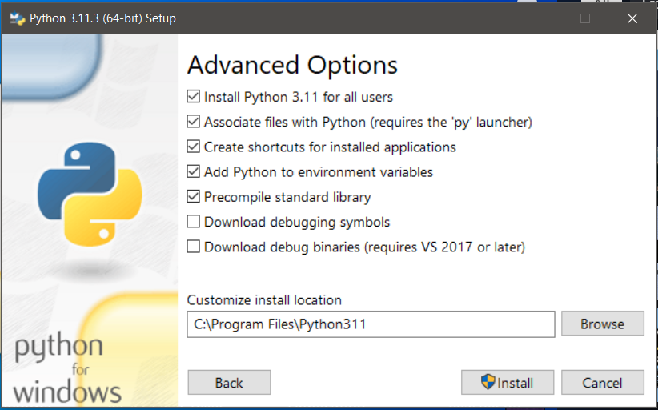
- After installation verify python IDE version by using the following command in Command Prompt.
python --version
- To know the pip version Run the command in Command Prompt.
pip –version
- Install flask in python run the command in Command Prompt.
py -m pip install flask
- To know the version of flask use the command in Command Prompt.
py -m flask --version

Experiment 9 (b)
Aim: Create HTML templates for web app with various menu items.
ALGORITHUM: To create menu items in flask follow the below steps.
- Create new folder Ex : flask-layout-example.
- In that flask-layout-example folder create two folders name as static and templates. In static folder add the images. In template folder create the html pages based on your requirement.
- Create the app.py in your main folder. Import all the necessary packages and write the code in app.py.
- After writing the code run the app.py file, you will get the url of the application copy and paste the path in browser and press enter button
example : http://127.0.0.1:5000
CODE :
- App.py
from flask import Flask, render_template, request
import os
import random
app = Flask(__name__)
def random_image():
img_dir = "./static"
img_list = os.listdir(img_dir)
return random.choice(img_list)
@app.route('/', methods=["GET", "POST"])
def index():
image = random_image()
return render_template('home.html', home_image = image)
@app.route('/register', methods=["GET", "POST"])
def register():
return render_template('registration.html')
@app.route('/login', methods=["GET", "POST"])
def login():
return render_template('login.html')
if __name__ == '__main__':
app.run(debug = True)
- home.html
{% extends 'layout.html' %}
{% block content %}
<section id="section-about" class="bg-grey">
<div class="container">
<div class="row pt-4">
<div class="col-md-6 col-sm-12">
<img src="{{url_for('static', filename=home_image)}}" alt="about image" class="img-responsive">
</div>
<div class="col-md-1"></div>
<div class="col-md-5 col-sm-12">
<div class="about-box">
<h2 class="box-title">Python Flask Example</h2>
<div class="tiny-border"></div>
<p>Lorem ipsum dolor sit amet, consectetur adipiscing elit, sed do eiusmod tempor incididunt ut labore et dolore magna aliqua.</p>
<ul class="list-style-1">
<li>Donec malesuada urna porta tellus feugiat</li>
<li>Nullam consequat lacus non luctus finibus.</li>
<li>Interdum et malesuada fames ac ante</li>
<li>Nam justo ipsum, sagittis sed hendrerit ac</li>
</ul>
<div class="divider-single"></div>
<a href="#" class="btn btn-primary btn-small">Get Started</a>
</div>
</div>
</div>
</div>
</section>
{% endblock %}
- login.html
{% extends 'layout.html' %}
{% block content %}
<div id="login">
<h3 class="text-center text-white pt-5">Login form</h3>
<div class="container">
<div id="login-row" class="row justify-content-center align-items-center">
<div id="login-column" class="col-md-6">
<div id="login-box" class="col-md-12">
<form id="login-form" class="form" action="" method="post">
<h3 class="text-center text-info">Login</h3>
<div class="form-group">
<label for="username" class="text-info">Username:</label><br>
<input type="text" name="username" id="username" class="form-control">
</div>
<div class="form-group">
<label for="password" class="text-info">Password:</label><br>
<input type="text" name="password" id="password" class="form-control">
</div>
<div class="form-group">
<label for="remember-me" class="text-info"><span>Remember me</span>Â <span><input id="remember-me" name="remember-me" type="checkbox"></span></label><br>
<input type="submit" name="submit" class="btn btn-info btn-md" value="submit">
</div>
<div id="register-link" class="text-right">
<a href="./register" class="text-info">Register here</a>
</div>
</form>
</div>
</div>
</div>
</div>
</div>
{% endblock %}
- registration.html
{% extends 'layout.html' %}
{% block content %}
<div class="container">

<div class="row justify-content-center">
<div class="col-12 col-md-8 col-lg-8 col-xl-6">
<div class="row">
<div class="col text-center">
<h1>Register</h1>
<p class="text-h3">Sign up now and get 3 months of free soup recipes</p>
</div>
</div>
<div class="row align-items-center">
<div class="col mt-4">
<input type="text" class="form-control" placeholder="Company Name">
</div>
</div>
<div class="row align-items-center mt-4">
<div class="col">
<input type="email" class="form-control" placeholder="Email">
</div>
</div>
<div class="row align-items-center mt-4">
<div class="col">
<input type="password" class="form-control" placeholder="Password">
</div>
<div class="col">
<input type="password" class="form-control" placeholder="Confirm Password">
</div>
</div>
<div class="row justify-content-start mt-4">
<div class="col">
<div class="form-check">
<label class="form-check-label">
<input type="checkbox" class="form-check-input">
I Read and Accept <a href="#">Terms and Conditions</a>
</label>
</div>

<button class="btn btn-primary mt-4">Submit</button>
</div>
</div>
</div>
</div>
</div>
{% endblock %}
- layout.html
<!doctype html>
<title>- Flask Template Demo</title>
<link rel="stylesheet" href="https://stackpath.bootstrapcdn.com/bootstrap/4.3.1/css/bootstrap.min.css">
<nav class="navbar navbar-expand-lg navbar-dark bg-dark">
<a class="navbar-brand" href="#">FLASK CRUD APP</a>
<button class="navbar-toggler" type="button" data-toggle="collapse" data-target="#navbarText" aria-controls="navbarText" aria-expanded="false" aria-label="Toggle navigation">
<span class="navbar-toggler-icon"></span>
</button>
<div class="collapse navbar-collapse" id="navbarText">
<ul class="navbar-nav mr-auto">
<li {% if request.endpoint == 'index' %} class="nav-item active" {% else %} class="nav-item" {% endif %}>
<a class="nav-link" href="/">Home <span class="sr-only">(current)</span></a>
</li>
<li {% if request.endpoint == 'register' %} class="nav-item active" {% else %} class="nav-item" {% endif %}>
<a class="nav-link" href="/register">Form <span class="sr-only">(current)</span></a>
</li>
<li {% if request.endpoint == 'login' %} class="nav-item active" {% else %} class="nav-item" {% endif %}>
<a class="nav-link" href="/login">Login</a>
</li>
</ul>
</div>
</nav>
<section class="content">
{% block content %}{% endblock %}
<script src="https://code.jquery.com/jquery-3.3.1.slim.min.js"></script>
<script src="https://cdnjs.cloudflare.com/ajax/libs/popper.js/1.14.7/umd/popper.min.js"></script>
<script src="https://stackpath.bootstrapcdn.com/bootstrap/4.3.1/js/bootstrap.min.js"></script>

</section>

Output Screens:
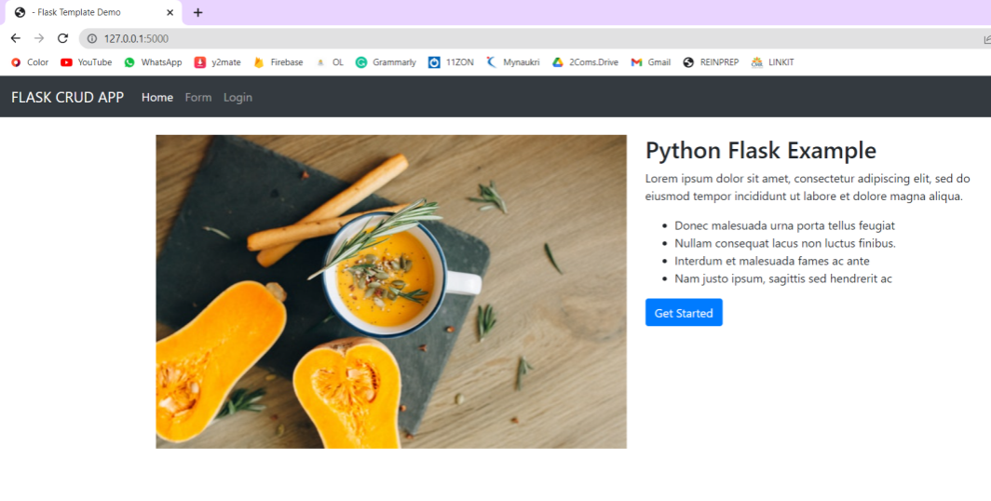
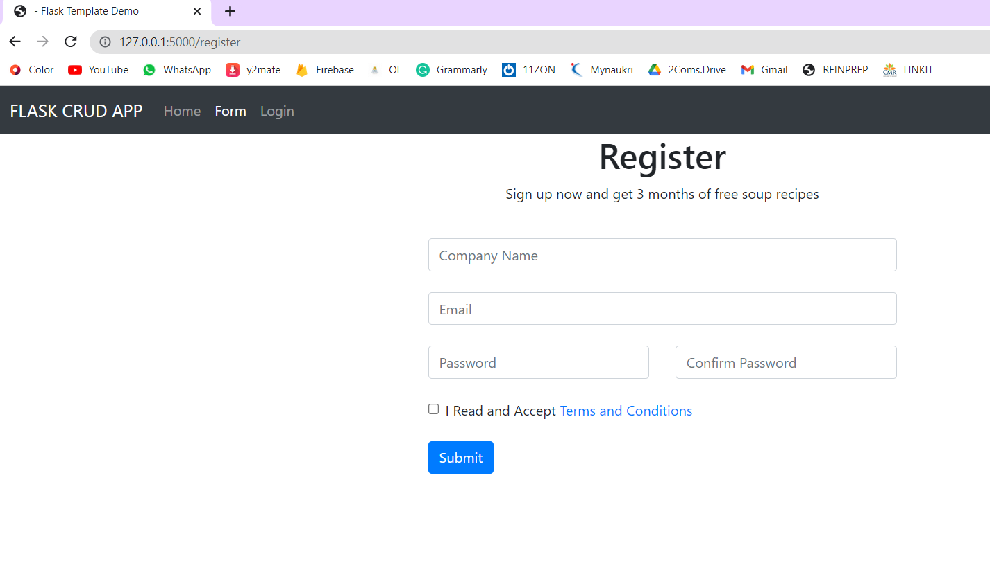
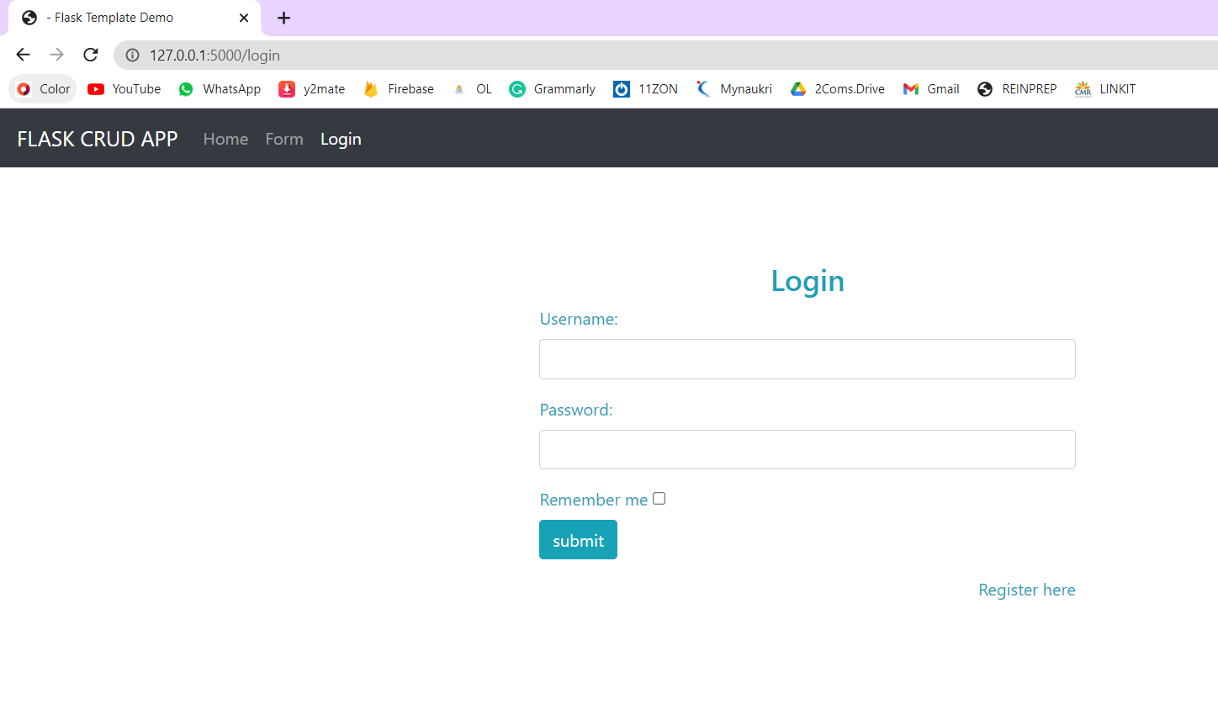
Experiment 10
Aim:Design a form to get some data at the client side from the user, and try to access this data on the server by using the POST request.
ALGORITHM:
- Create new folder Ex : flask-example.
- In flask-example folder create login.html page .
- Create a form to get some data at the client side from the user access this data on the server by using the POST request.
- Create the app.py in your main folder. Import all the necessary packages and write the code in app.py.
- Start the development server by running the script using python app.py and open login.html on the web browser.
- Give the required input and click Submit the form data is sent to the development server by using the post method.
CODE :
- Login.html
<html>
<body>
<formaction = "http://localhost:5000/login"method = "post">
<table>
<tr><td>Name</td>
<td><inputtype ="text"name ="uname"></td></tr>
<tr><td>Password</td>
<td><inputtype ="password"name ="pass"></td></tr>
<tr><td><inputtype = "submit"></td></tr>
</table>
</form>
</body>
</html>

- app.py
from flask import *
app = Flask(__name__)

@app.route('/login',methods = ['POST'])
def login():
uname=request.form['uname']
passwrd=request.form['pass']
if uname=="google"and passwrd=="google":
return"Welcome %s" %uname

if __name__ == '__main__':
app.run(debug = True)
Output Screens:
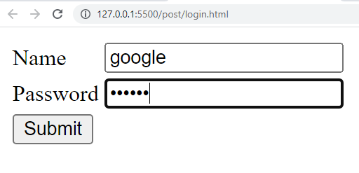

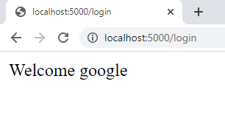

Experiment 11
Aim: Develop a web app with login and welcome pages When the user submits a user name and password validate and verify user details on success navigate to the welcome page.
ALGORITHM:
- Create new folder Ex : flask-example.
- In flask-example folder create login.html page .
- Create a form to get some data at the client side data sent using the get() method is retrieved on the development server.
- Create the app.py in your main folder. Import all the necessary packages and write the code in app.py.
- Start the development server by running the script using python app.py and open login.html on the web browser.
- Give the required input and click Submit the form, here check the URL which also contains the data sent with the request to the server.
CODE :
      - Login.html
<html>
<body>
<formaction = "http://localhost:5000/login"method="get">
<table>
<tr><td>Name</td>
<td><inputtype ="text"name ="uname"></td></tr>
<tr><td>Password</td>
<td><inputtype ="password"name ="pass"></td></tr>
<tr><td><inputtype = "submit"></td></tr>
</table>
</form>
</body>
</html>

      - app.py
from flask import *
app = Flask(__name__)

@app.route('/login',methods = ['GET'])
def login():
uname=request.args.get('uname')
passwrd=request.args.get('pass')
if uname=="google" and passwrd=="google":
return "Data Retrieved %s" %uname

if __name__ == '__main__':
app.run(debug = True)
Output Screens:
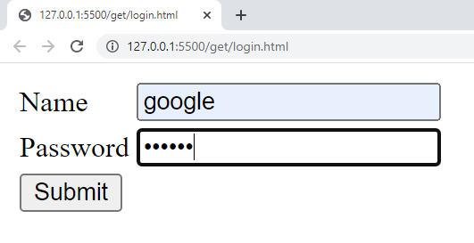

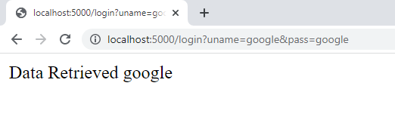

Experiment 12
Aim: Implement a simple Chabot for answering python questions from text file.
ALGORITHM:
- Create new Folder Ex: ChatBoat
- In that folder create new python files a) long_responses.py b) myChatboat.py.
- Install all the necessary packages by using cmd.
- Add the text information of questions and answers in a file.
Code :
- long_responses.py
import random
R_EATING = "I don't like eating anything because I'm a bot obviously!"
R_ADVICE = "If I were you, I would go to the internet and type exactly what you wrote there!"
def unknown():
response = ["Could you please re-phrase that? ",
"...",
"Sounds about right.",
"What does that mean?"][
random.randrange(4)]
return response
- myChatboat.py
import re
import long_responses as long
def message_probability(user_message, recognised_words, single_response=False, required_words=[]):
message_certainty = 0
has_required_words = True
# Counts how many words are present in each predefined message
for word in user_message:
if word in recognised_words:
message_certainty += 1
# Calculates the percent of recognised words in a user message
percentage = float(message_certainty) / float(len(recognised_words))
# Checks that the required words are in the string
for word in required_words:
if word not in user_message:
has_required_words = False
break
# Must either have the required words, or be a single response
if has_required_words or single_response:
return int(percentage * 100)
else:
return 0
def check_all_messages(message):
highest_prob_list = {}
# Simplifies response creation / adds it to the dict
def response(bot_response, list_of_words, single_response=False, required_words=[]):
nonlocal highest_prob_list
highest_prob_list[bot_response] = message_probability(message, list_of_words, single_response, required_words)
# Responses -------------------------------------------------------------------------------------------------------
response('Hello!', ['hello', 'hi', 'hey', 'sup', 'heyo'], single_response=True)
response('See you!', ['bye', 'goodbye'], single_response=True)
response('I\'m doing fine, and you?', ['how', 'are', 'you', 'doing'], required_words=['how'])
response('You\'re welcome!', ['thank', 'thanks'], single_response=True)
response('Thank you!', ['i', 'love', 'code', 'palace'], required_words=['code', 'palace'])
# Longer responses
response(long.R_ADVICE, ['give', 'advice'], required_words=['advice'])
response(long.R_EATING, ['what', 'you', 'eat'], required_words=['you', 'eat'])
best_match = max(highest_prob_list, key=highest_prob_list.get)
# print(highest_prob_list)
# print(f'Best match = {best_match} | Score: {highest_prob_list[best_match]}')
return long.unknown() if highest_prob_list[best_match] < 1 else best_match
# Used to get the response
def get_response(user_input):
split_message = re.split(r'\s+|[,;?!.-]\s*', user_input.lower())
response = check_all_messages(split_message)
return response
# Testing the response system
while True:
print('Bot: ' + get_response(input('You: ')))
Output Screens:
